**IFT 530 – ADVANCED DATABASE MANAGEMENT SYSTEMS**

**FINAL PROJECT**

**GROUP NUMBER 30**

**APRIL 24, 2023**

**BLOOD BANKING DATABASE MANAGEMENT SYSTEM**

**TEAM MEMBERS (FINAL Group Project 30)**

**Mohan Karthik VijayaKumar (1228885205)**

**Sumasree Battula (1231053267)**

**CODE OR SCRIPT:**

/*

** Author: Sumasree Battula

** ASU ID: 1231053267

** Course: IFT-530

** Group Number : 30

** Team members:Mohan Karthik VijayaKumar(ASU ID: 1231053267),Sumasree Battula.

** SQL Server Version: Microsoft SQL Server 2012 (SP1)

** History: Assignment on Security

** Date created: 04/23/2024

*/

create database Grp30_DB

go

use Grp30_DB

go

CREATE SCHEMA Blood_bank

CREATE TABLE Blood_bank.donor(

donor_id INT NOT NULL,

donor_name VARCHAR(50) NOT NULL,

age INT NOT NULL,

gender VARCHAR(1) NOT NULL,

cityName VARCHAR(50) NOT NULL,

bloodTypeCode VARCHAR(3) NOT NULL,

last_Donated VARCHAR(10) NOT NULL,

CONSTRAINT donor_PK PRIMARY KEY(donor_id),

);

CREATE TABLE Blood_bank.donation(

donation_id INT NOT NULL,

donor_id INT NOT NULL,

donation_date VARCHAR(8) NOT NULL,

donation_amount INT NOT NULL,

CONSTRAINT donation_PK PRIMARY KEY(donation_id),

);

CREATE TABLE Blood_bank.inventory(

bloodTypeCode VARCHAR(3) NOT NULL,

expiration_date VARCHAR(8)NOT NULL,

quantity_available INT NOT NULL,

CONSTRAINT inventory_PK PRIMARY KEY(bloodTypeCode),

);

CREATE TABLE Blood_bank.Patient(

patient_id INT NOT NULL,

patient_name VARCHAR(50)NOT NULL,

patient_age INT NOT NULL,

patient_gender VARCHAR(1)NOT NULL,

hospital_id INT NOT NULL,

phone_num VARCHAR(10) NOT NULL,

email_id VARCHAR(50) NOT NULL,

bloodTypeCode VARCHAR(3) NOT NULL,

CONSTRAINT patient_PK PRIMARY KEY(patient_id),

CONSTRAINT patient_UC1 UNIQUE(phone_num),

CONSTRAINT patient_UC2 UNIQUE(email_id),

);

CREATE TABLE Blood_bank.Hospital(

hospital_id INT NOT NULL,

hospital_name VARCHAR(60) NOT NULL,

city VARCHAR(40) NOT NULL,

CONSTRAINT hospital_PK PRIMARY KEY(hospital_id),

);

CREATE TABLE Blood_bank.Request(

req_id INT NOT NULL,

req_date VARCHAR(8)NOT NULL,

patient_id INT NOT NULL,

donor_id INT NOT NULL,

CONSTRAINT req_PK PRIMARY KEY(req_id),

);

ALTER TABLE Blood_bank.donor ADD CONSTRAINT donation_FK FOREIGN KEY (bloodTypeCode)

REFERENCES Blood_bank.inventory(bloodTypeCode)

ALTER TABLE Blood_bank.donation ADD CONSTRAINT donation_FK1 FOREIGN KEY (donor_id)

REFERENCES Blood_bank.donor(donor_id)

ALTER TABLE Blood_bank.Patient ADD CONSTRAINT patient_FK1 FOREIGN KEY (hospital_id)

REFERENCES Blood_bank.Hospital(hospital_id)

ALTER TABLE Blood_bank.Request ADD CONSTRAINT req_FK1 FOREIGN KEY (patient_id)

REFERENCES Blood_bank.Patient(patient_id)

ALTER TABLE Blood_bank.Request ADD CONSTRAINT req_FK2 FOREIGN KEY (donor_id)

REFERENCES Blood_bank.donor(donor_id)

INSERT INTO Blood_bank.inventory(bloodTypeCode, expiration_date, quantity_available)

VALUES

('A+','20240801', 45),

('B+','20240412', 66),

('O-','20240506', 35),

('AB+','20241228', 75),

('B-','20241104', 100),

('A-','20240301', 40),

('O+','20240707', 85),

('AB-','20240909', 25);

select * from Blood_bank.inventory;

INSERT INTO Blood_bank.donor(donor_id, donor_name, age, gender, cityName, bloodTypeCode, last_Donated)

VALUES

(101,'Suma', 25,'F','Tempe','A+','20230402'),

(102,'Mohan', 27,'M','Los Angeles','B-','20230724'),

(103,'Sanjana S', 22,'F','Mesa','O-','20230802'),

(104,'Jananiya', 32,'F','New York','A+','20231104'),

(105,'Karthik', 21,'M','Sandiego','B+','20230101'),

(106,'Aravind', 35,'M','Chicago','A+','20230608'),

(107,'Aradya', 38,'M','Portland','O+','20230808'),

(108,'Koushal', 29,'M','Denver','AB-','20230211'),

(109,'Virat', 23,'M','Michigan','B-','20230703'),

(110,'Rachana', 28,'F','Boston','AB+','20231111');

select * from Blood_bank.donor;

INSERT INTO Blood_bank.donation(donation_id, donor_id, donation_date, donation_amount)

VALUES

(1001, 101,'20230402', 750),

(1002, 102,'20230724', 250),

(1003, 103,'20230802', 550),

(1004, 104,'20231104', 650),

(1005, 105,'20230101', 150),

(1006, 106,'20230608', 350),

(1007, 107,'20230808', 650),

(1008, 108,'20230211', 850),

(1009, 109,'20230703', 950),

(1010, 110,'20231111', 250),

(1011, 101,'20220101', 550),

(1012, 102,'20220308', 750),

(1013, 103,'20220510', 150),

(1014, 104,'20220922', 650),

(1015, 105,'20220607', 250),

(1016, 106,'20220218', 150),

(1017, 107,'20221113', 450),

(1018, 108,'20220427', 750),

(1019, 109,'20220623', 850),

(1020, 110,'20221010', 950);

select * from Blood_bank.donation;

INSERT INTO Blood_bank.Hospital(hospital_id, hospital_name, city)

VALUES

(11,'Tempe General Medical Hospital','Tempe'),

(21,'Phoenix Medical Hospital','Phoenix'),

(31,'Mesa Central Hospital','Mesa'),

(41,'Ohio State Hospital','Ohio'),

(51,'Texas Elementary Hospital','Texas'),

(61,'Portland Emergency Services Hospital','Oregon'),

(71,'Boston State Medical Hospital','Boston'),

(81,'Michigan Health Center','Michigan'),

(91,'Oregon State Medical Center','Oregon'),

(101,'Pittsburgh State Hospital','Pitssburgh');

select * from Blood_bank.Hospital;

INSERT INTO Blood_bank.Patient(patient_id, patient_name, patient_age, patient_gender, hospital_id, phone_num, email_id, bloodTypeCode)

VALUES

(1,'Vrinda A', 22,'F', 11,'9666677775','Vrinda@gmail.com','B+'),

(2,'Rishith S', 45,'M', 21,'9845672323','Rishith@gmail.com','B-'),

(3,'Priyanka L', 66,'F', 31,'9876767633','Priyanka@gmail.com','A+'),

(4,'Sriraj M', 51,'M', 41,'7778883425','Sriraj@gmail.com','AB+'),

(5,'Lohitha', 25,'F', 51,'6308976213','Lohitha@gmail.com','O-'),

(6,'Vasanth A', 35,'F', 61,'8745672333','Vasanth@gmail.com','A+'),

(7,'Laxmi S', 45,'F', 71,'7893421156','Laxmi@gmail.com','O+'),

(8,'Akash L', 25,'M', 81,'9845672345','Akasha@gmail.com','AB-'),

(9,'Yudisha M', 23,'F', 91,'7856342222','Yudisha@gmail.com','B+'),

(10,'Rohith', 29,'M', 101,'6739056434','Rohith@gmail.com','B-');

select * from Blood_bank.Patient;

INSERT INTO Blood_bank.Request(req_id, req_date, patient_id, donor_id)

VALUES

(111,'20240202', 1, 101),

(222,'20240305', 2, 102),

(333,'20240228', 3, 103),

(444,'20240101', 4, 104),

(555,'20240501', 5, 105),

(666,'20240202', 6, 106),

(777,'20240305', 7, 107),

(888,'20240228', 8, 108),

(999,'20240412', 9, 109),

(1099,'20241012', 10, 110),

(1199,'20241123', 1, 101),

(1299,'20240424', 2, 102),

(1399,'20240126', 3, 103),

(1499,'20240207', 4, 104),

(1599,'20240202', 5, 105),

(1699,'20240809', 6, 106),

(1799,'20240707', 7, 107),

(1899,'20240907', 8, 108),

(1999,'20240606', 9, 109),

(2099,'20240819', 10, 110);

select * from Blood_bank.Request;

**OUTPUT SNIPPETS: Database schema table creations:**

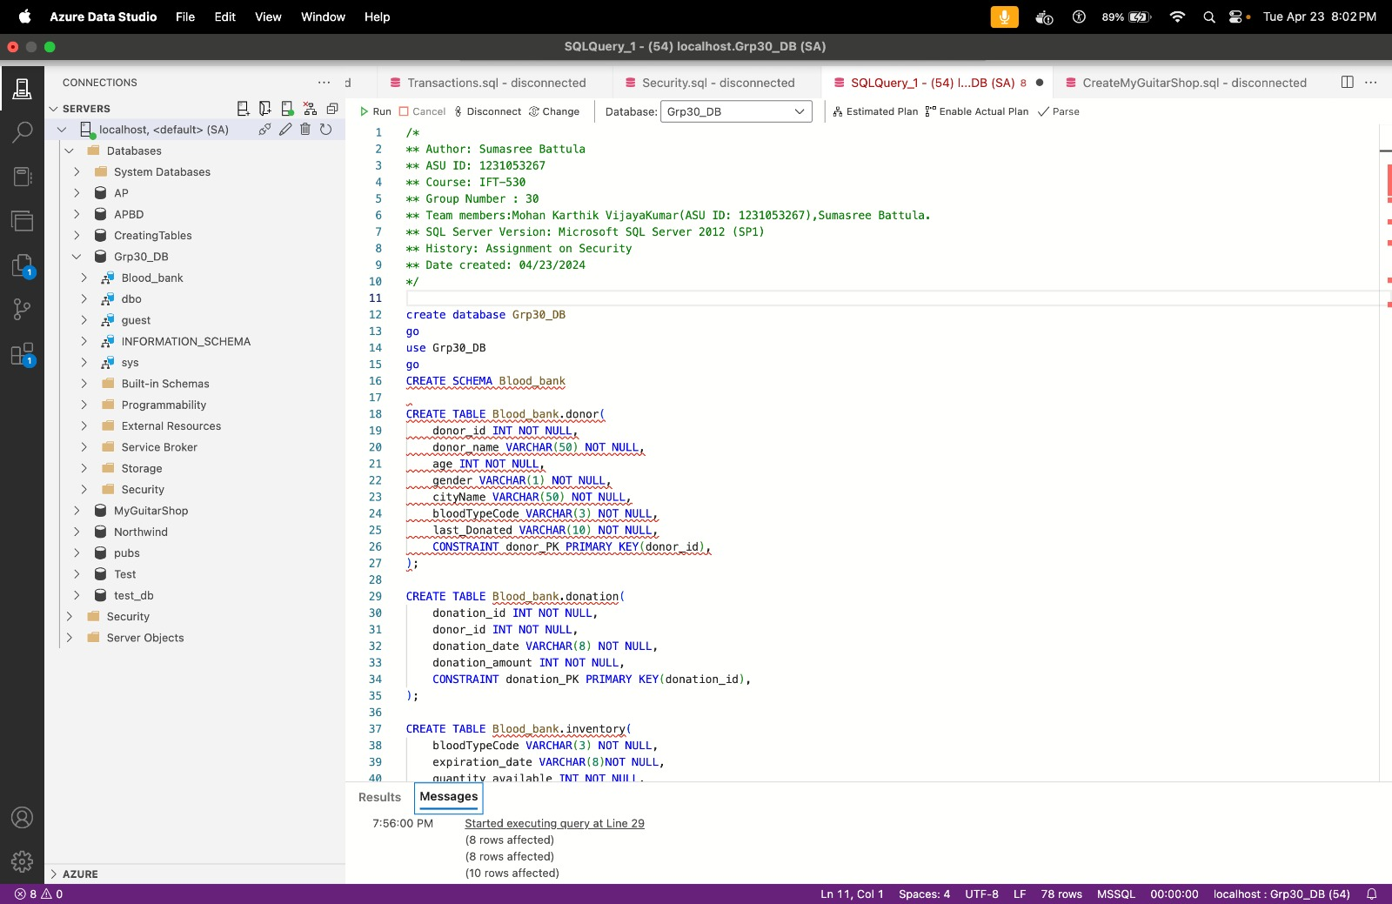

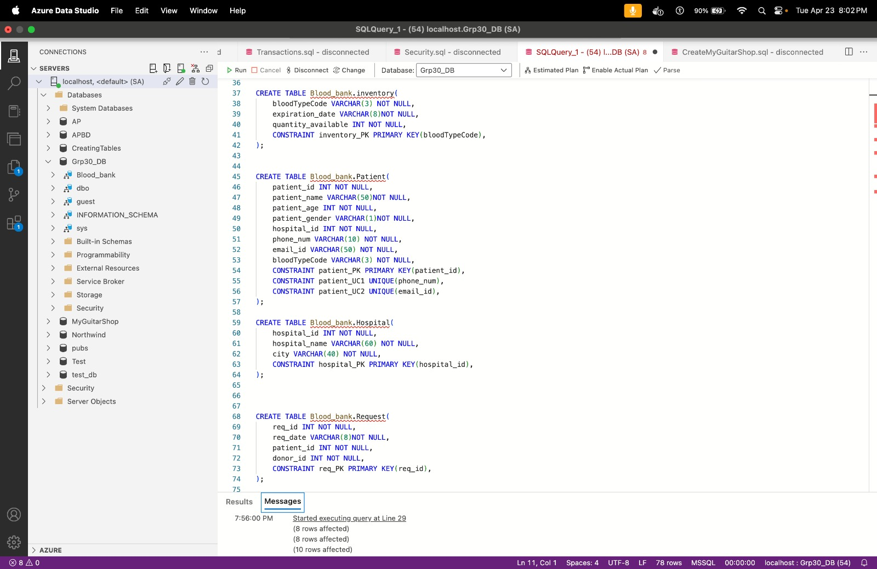

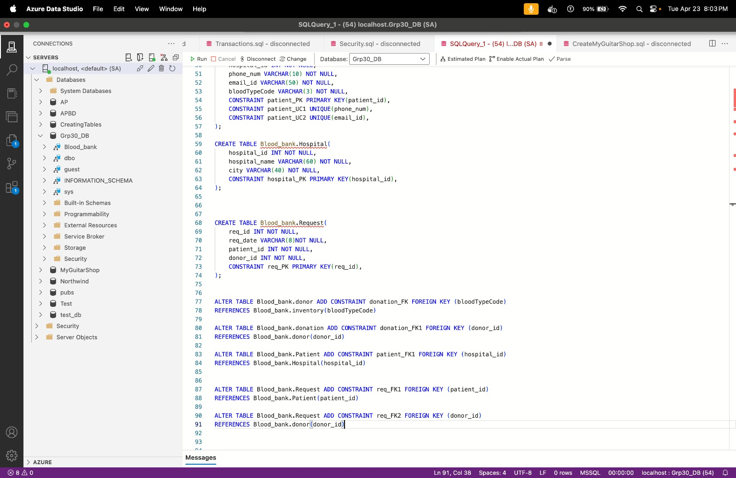

For Inventory table: Inserting values to inventory table and testcase statements using select statement

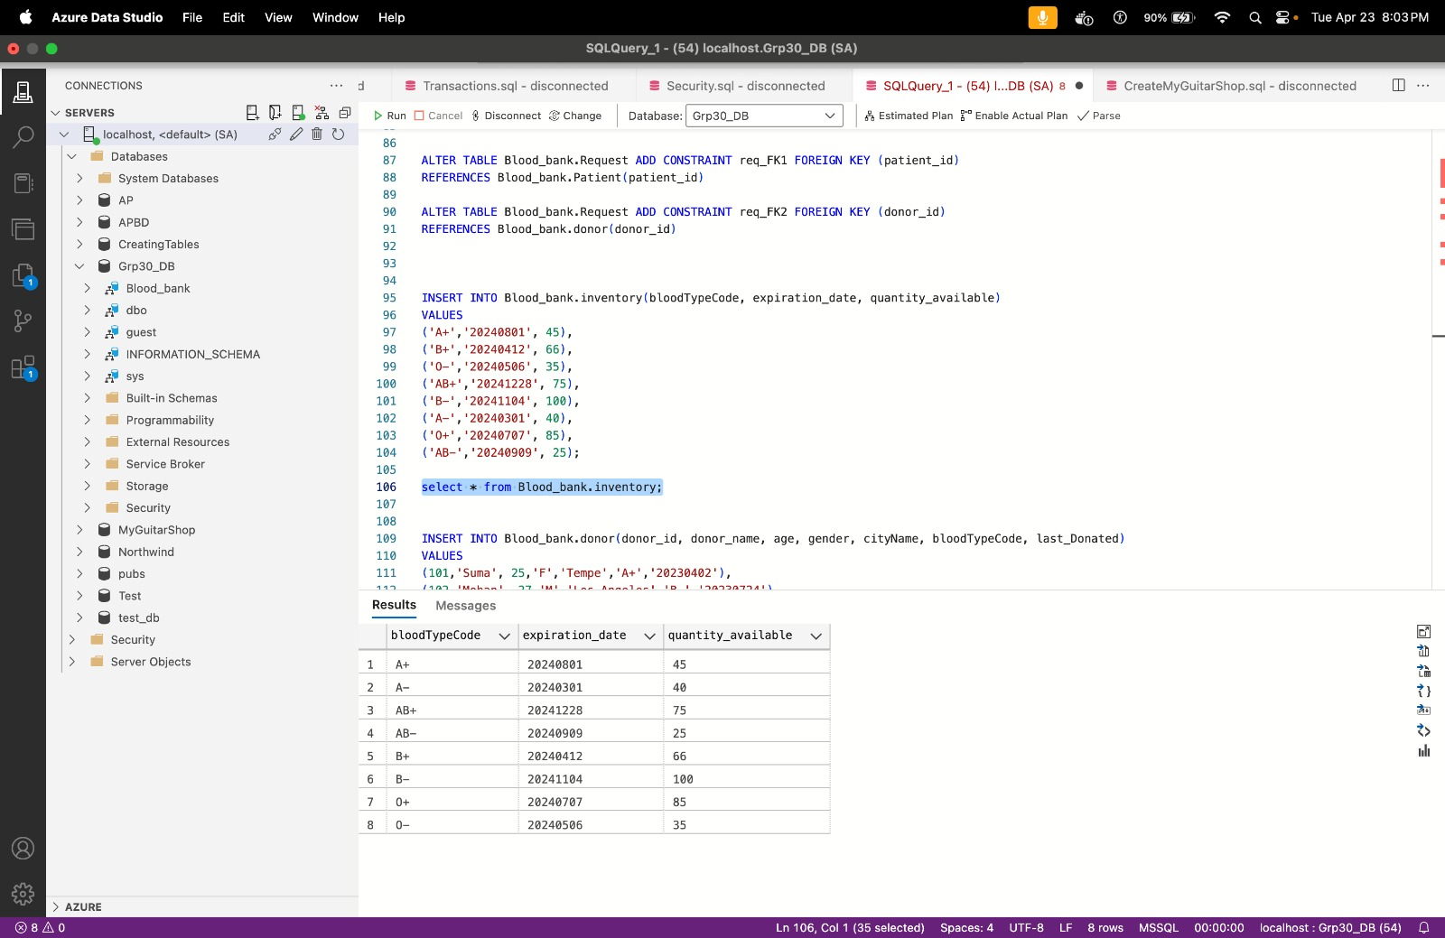

For Donor table: Inserting values to donor table and testcase statements using select statement

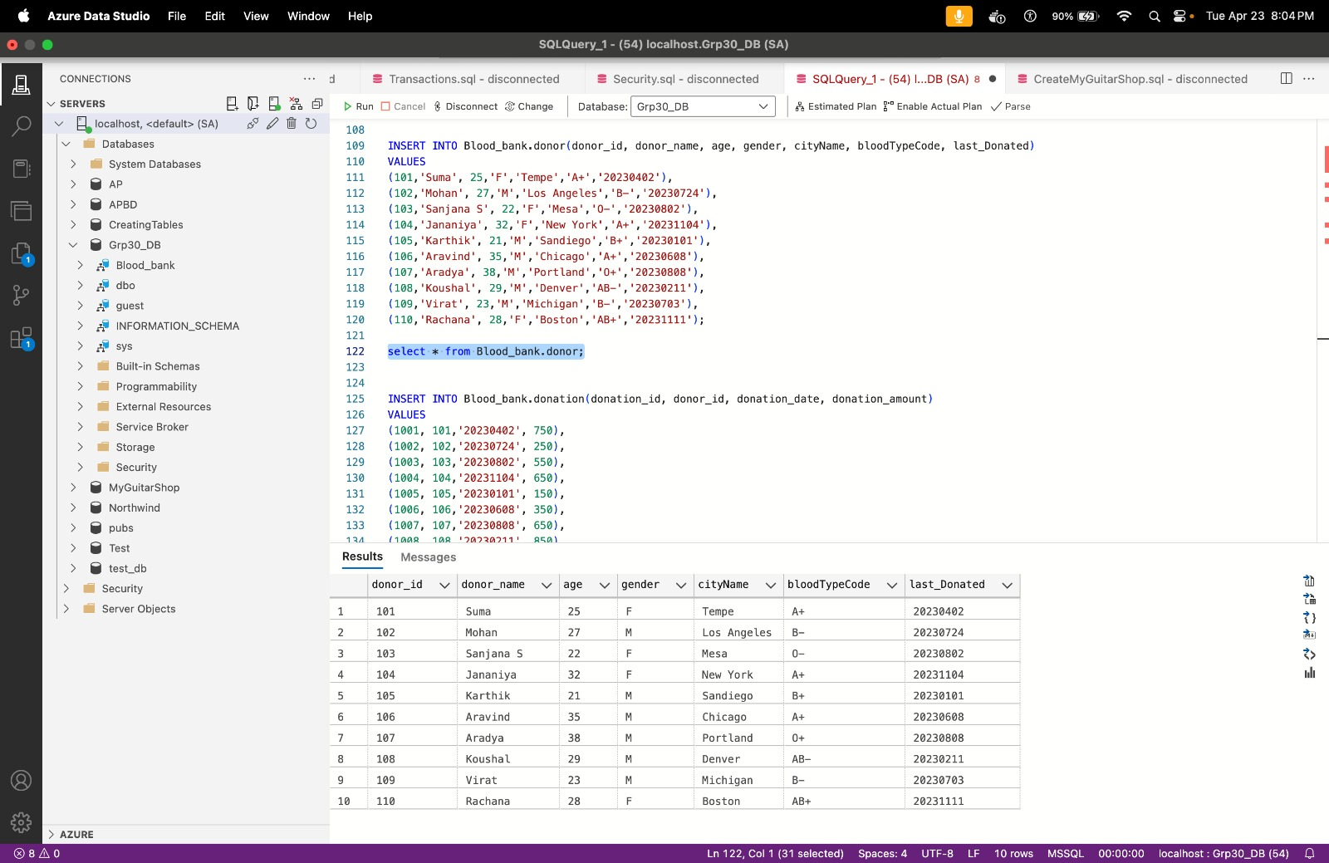For Donation table: Inserting values to donation table and testcase statements using select statement

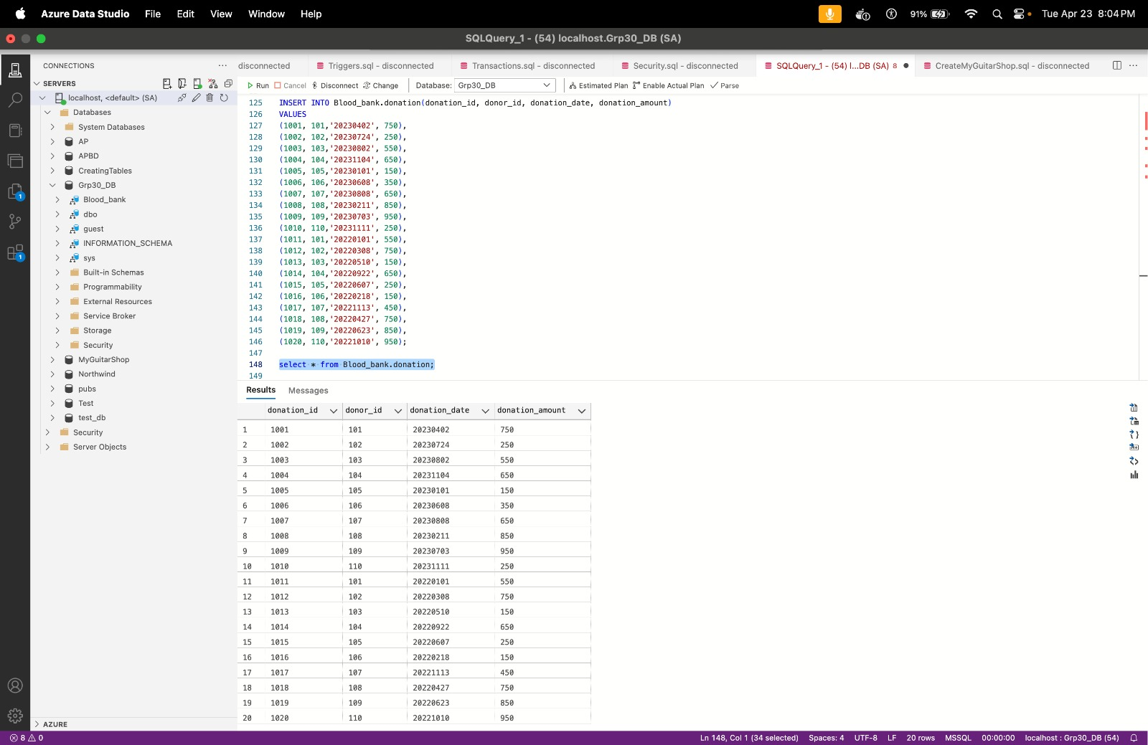

For Hospital table: Inserting values to hospital table and testcase statements using select statement

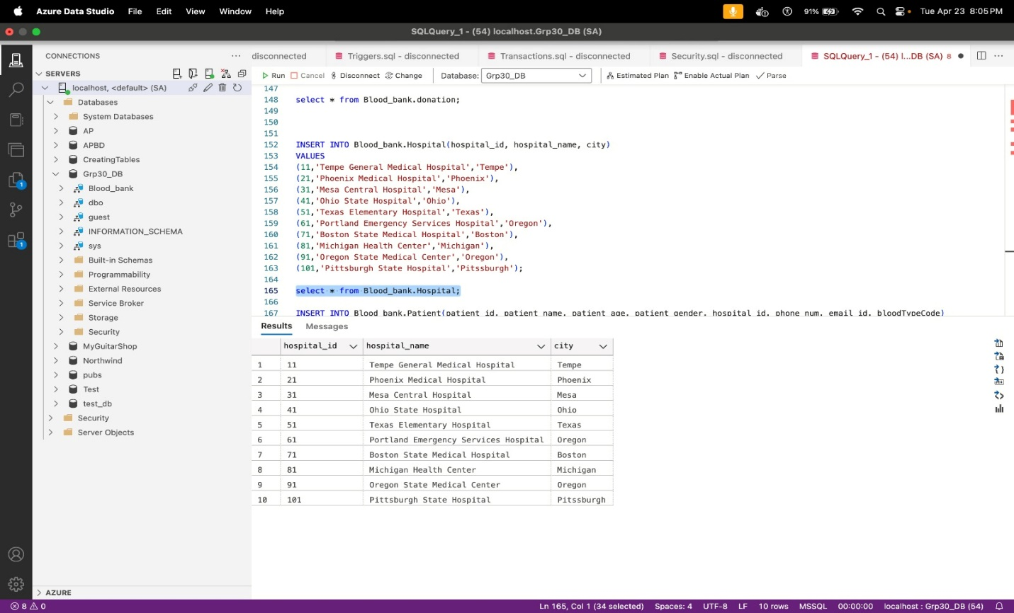

For Patient table: Inserting values to Patient table and testcase statements using select statement

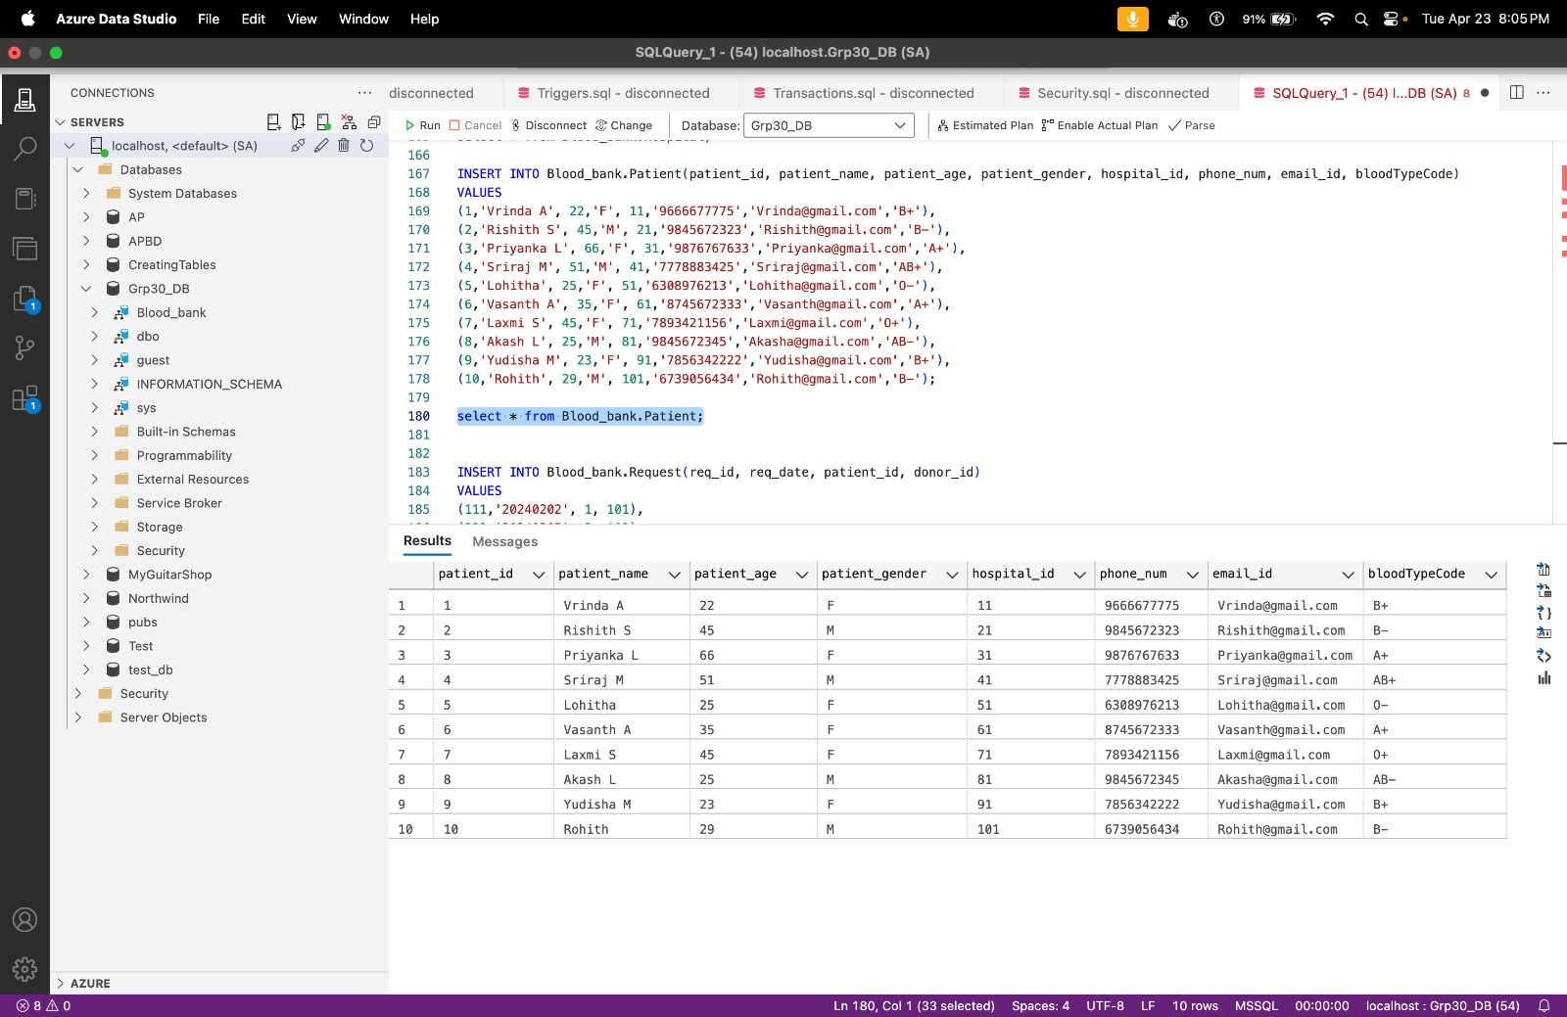

For Request table: Inserting values to Request table and testcase statements using select statement

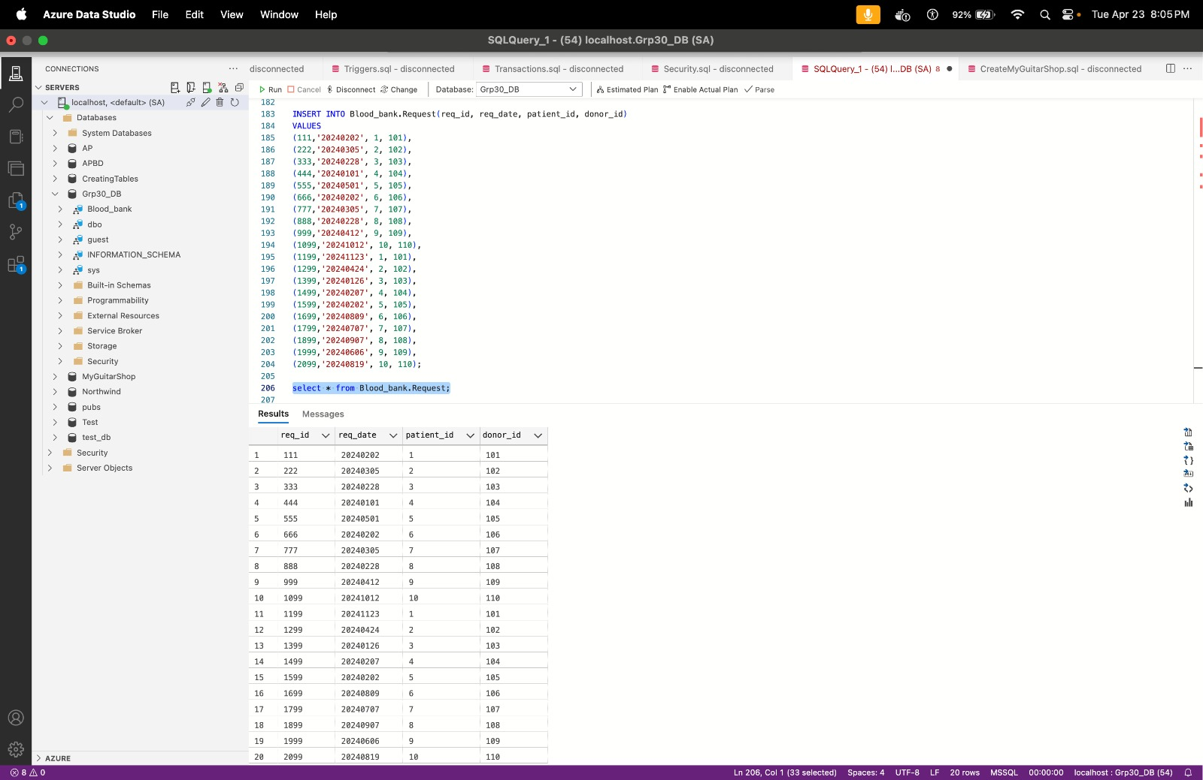

**Summary:**

In the above SQL script, we created a database named Grp30_DB with a schema called Blood_bank. Within this schema, we defined tables for donors, donations, inventory, patients, hospitals, and requests. Each table contains relevant information such as donor details, donation records, inventory of blood types, patient information, hospital details, and donation requests. Foreign key constraints were added to maintain data integrity. Data was inserted into each table to populate them. This script sets up a basic blood bank database schema to manage blood donation operations effectively.

**ERD diagram:**

The ERD illustrates multiple tables connected through foreign key relationships, each representing entities like donors, donations, inventory, patients, hospitals, and requests. For instance, the "donation" table links to "donor" via the donor_id foreign key. Likewise, the "request" table connects to both "patient" and "donor" through patient_id and donor_id foreign keys, respectively. This depiction showcases the flow and interaction of data within the blood bank database, aiding in the effective management of donor, patient, and inventory information.

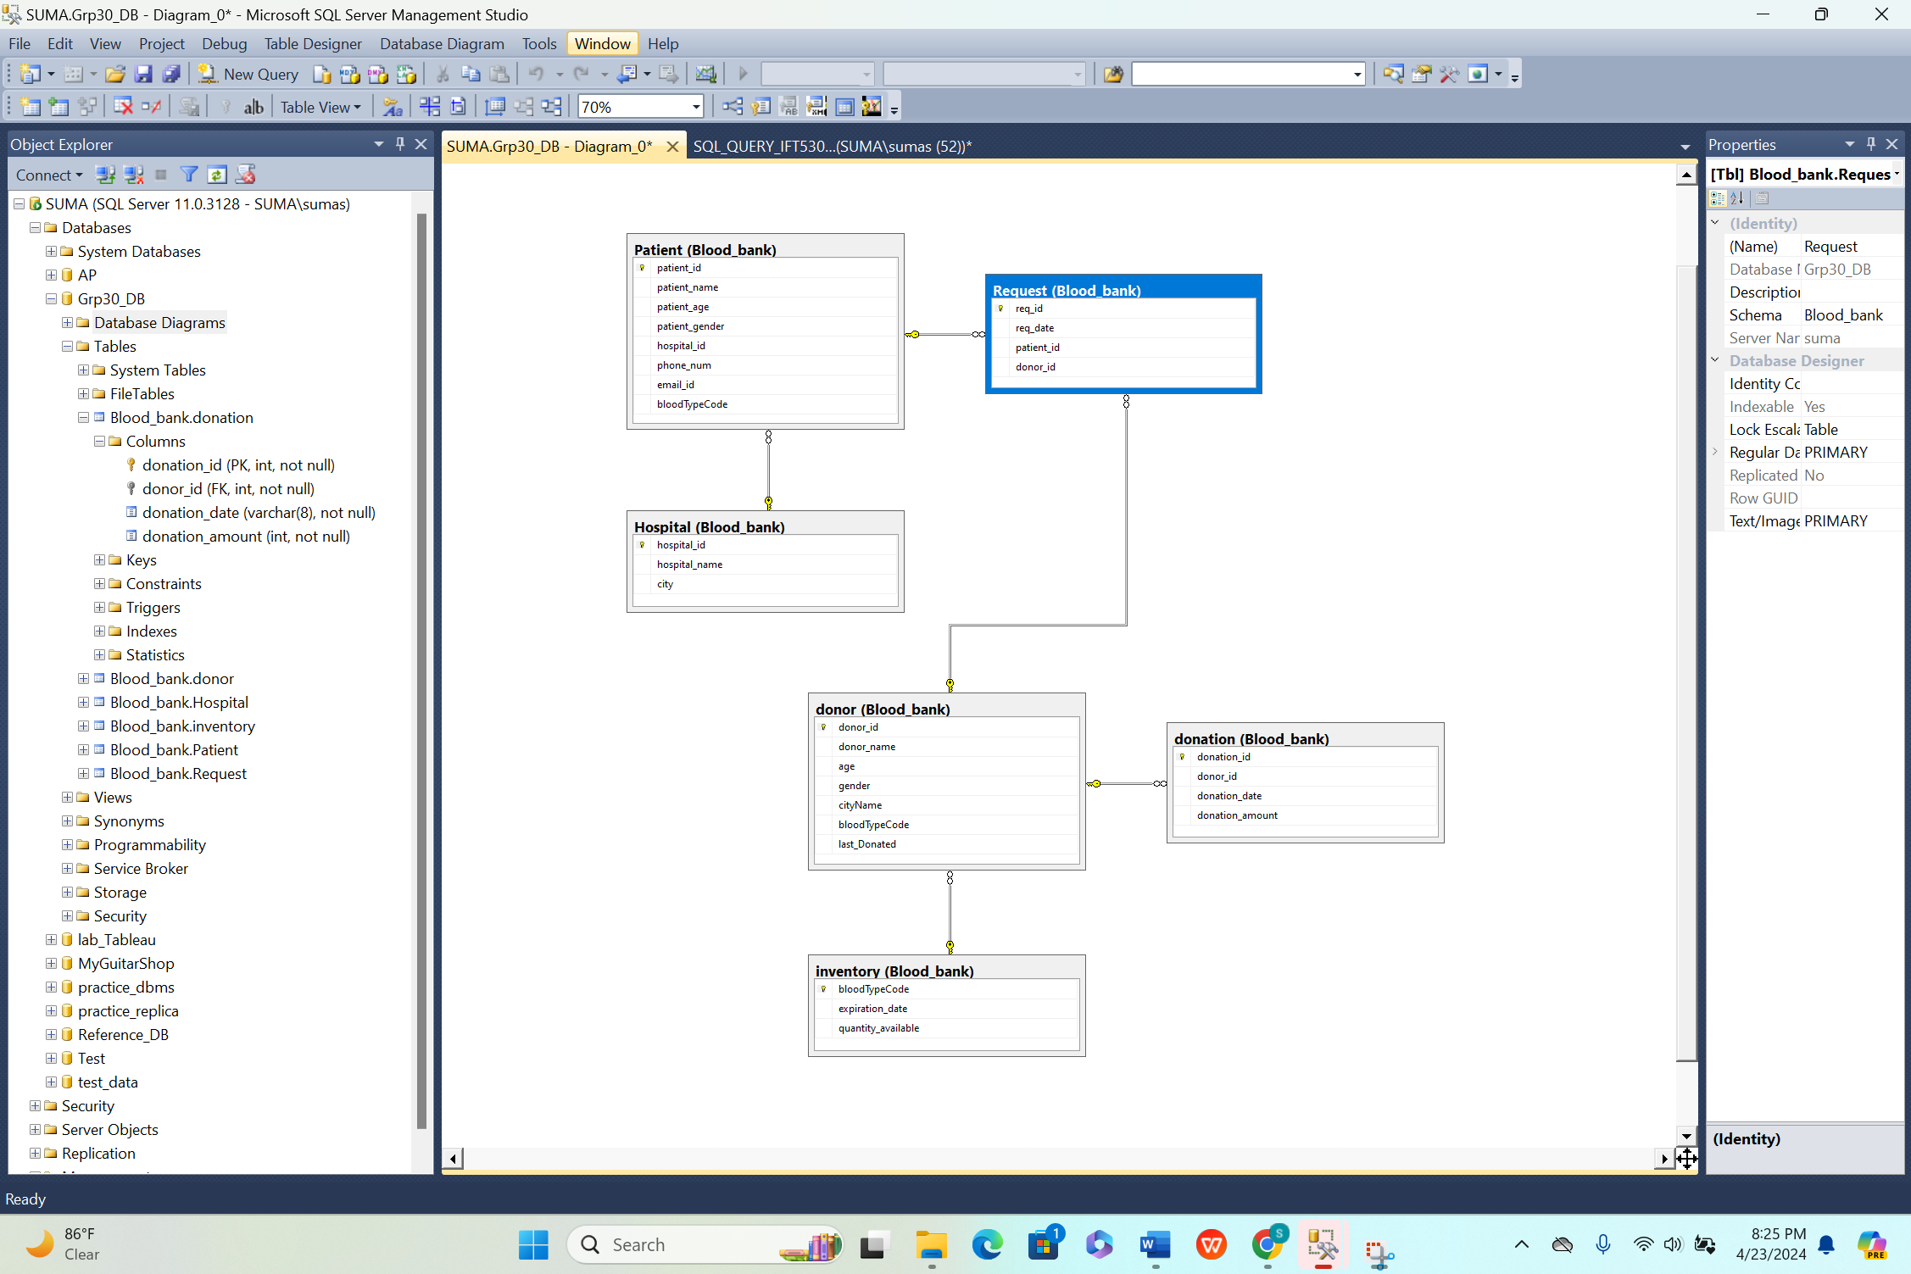

**Views creations:**

**View 1: Active Blood Requests (active_blood_requests)**

CODE:

/*

** Author: Sumasree Battula

** ASU ID: 1231053267

** Course: IFT-530

** Group Number : 30

** Team members:Mohan Karthik VijayaKumar(ASU ID: 1231053267),Sumasree Battula.

** SQL Server Version: Microsoft SQL Server 2012 (SP1)

** History: Assignment on Security

** Date created: 04/23/2024

*/

-- VIEW 1: Active Blood Requests (active_blood_requests)

CREATE VIEW active_blood_requests

AS

SELECT

r.req_id,

r.req_date,

p.patient_name,

p.bloodTypeCode,

h.hospital_name,

h.city

FROM Blood_bank.Request r

INNER JOIN Blood_bank.Patient p ON r.patient_id = p.patient_id

INNER JOIN Blood_bank.Hospital h ON p.hospital_id = h.hospital_id

WHERE r.req_date >= '20240228';

Select * from active_blood_requests

Code and output snippet: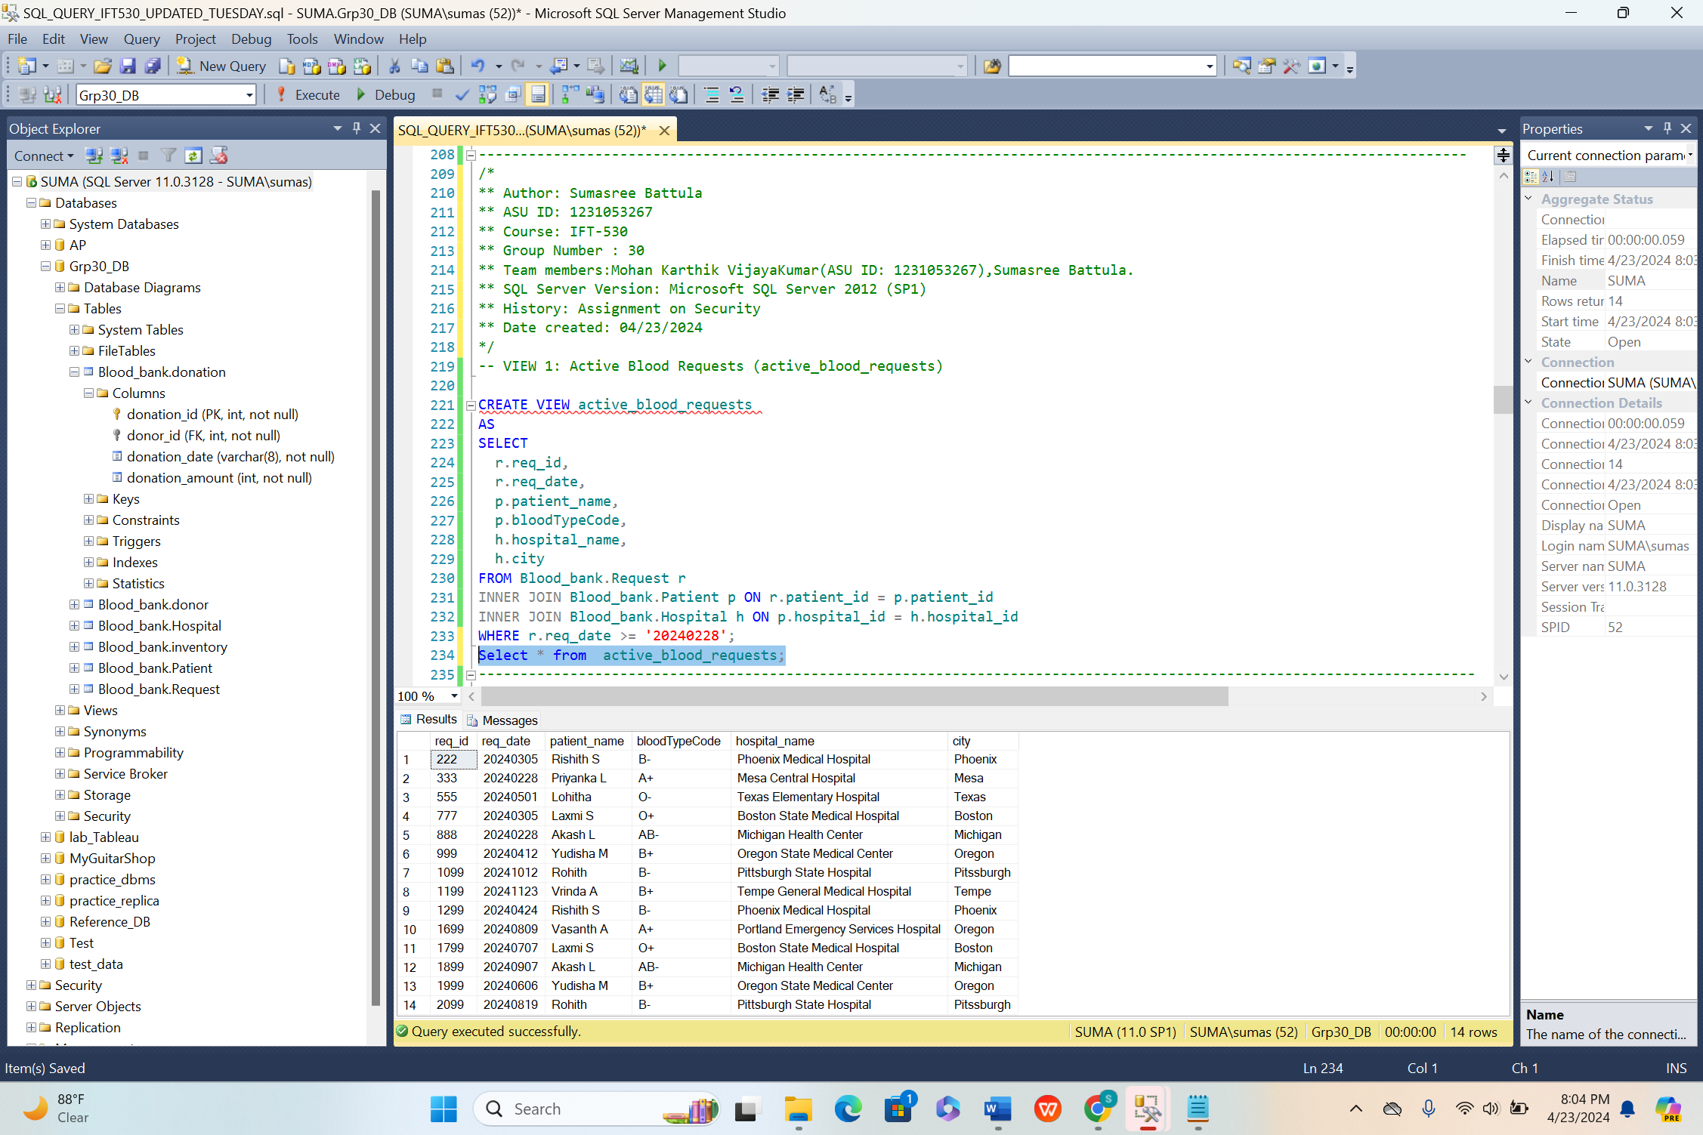

This query shows a list of up-to-date blood requests. It includes important details like the request ID, date, patient name, needed blood type, hospital, and city. This helps blood bank staff and hospitals easily see what blood is currently needed, allowing them to better manage requests and distribute blood supplies. By only showing requests from a chosen date onwards, they can focus on what's urgent, making sure blood gets to where it's needed most.

**View 2:**

**Code:**

-- VIEW 2 : Active Blood Donations from Specific Blood Types (active_donations_by_type)

CREATE VIEW active_donations_by_type

AS

SELECT

d.donor_name,

d.cityName,

do.donation_date,

do.donation_amount,

d.bloodTypeCode

FROM Blood_bank.donation do

INNER JOIN Blood_bank.donor d ON do.donor_id = d.donor_id

WHERE do.donation_date >= '20230501'

AND (d.bloodTypeCode = 'A+' OR d.bloodTypeCode = 'O+');

Select * from active_donations_by_type;

**Code and Output snippet:**

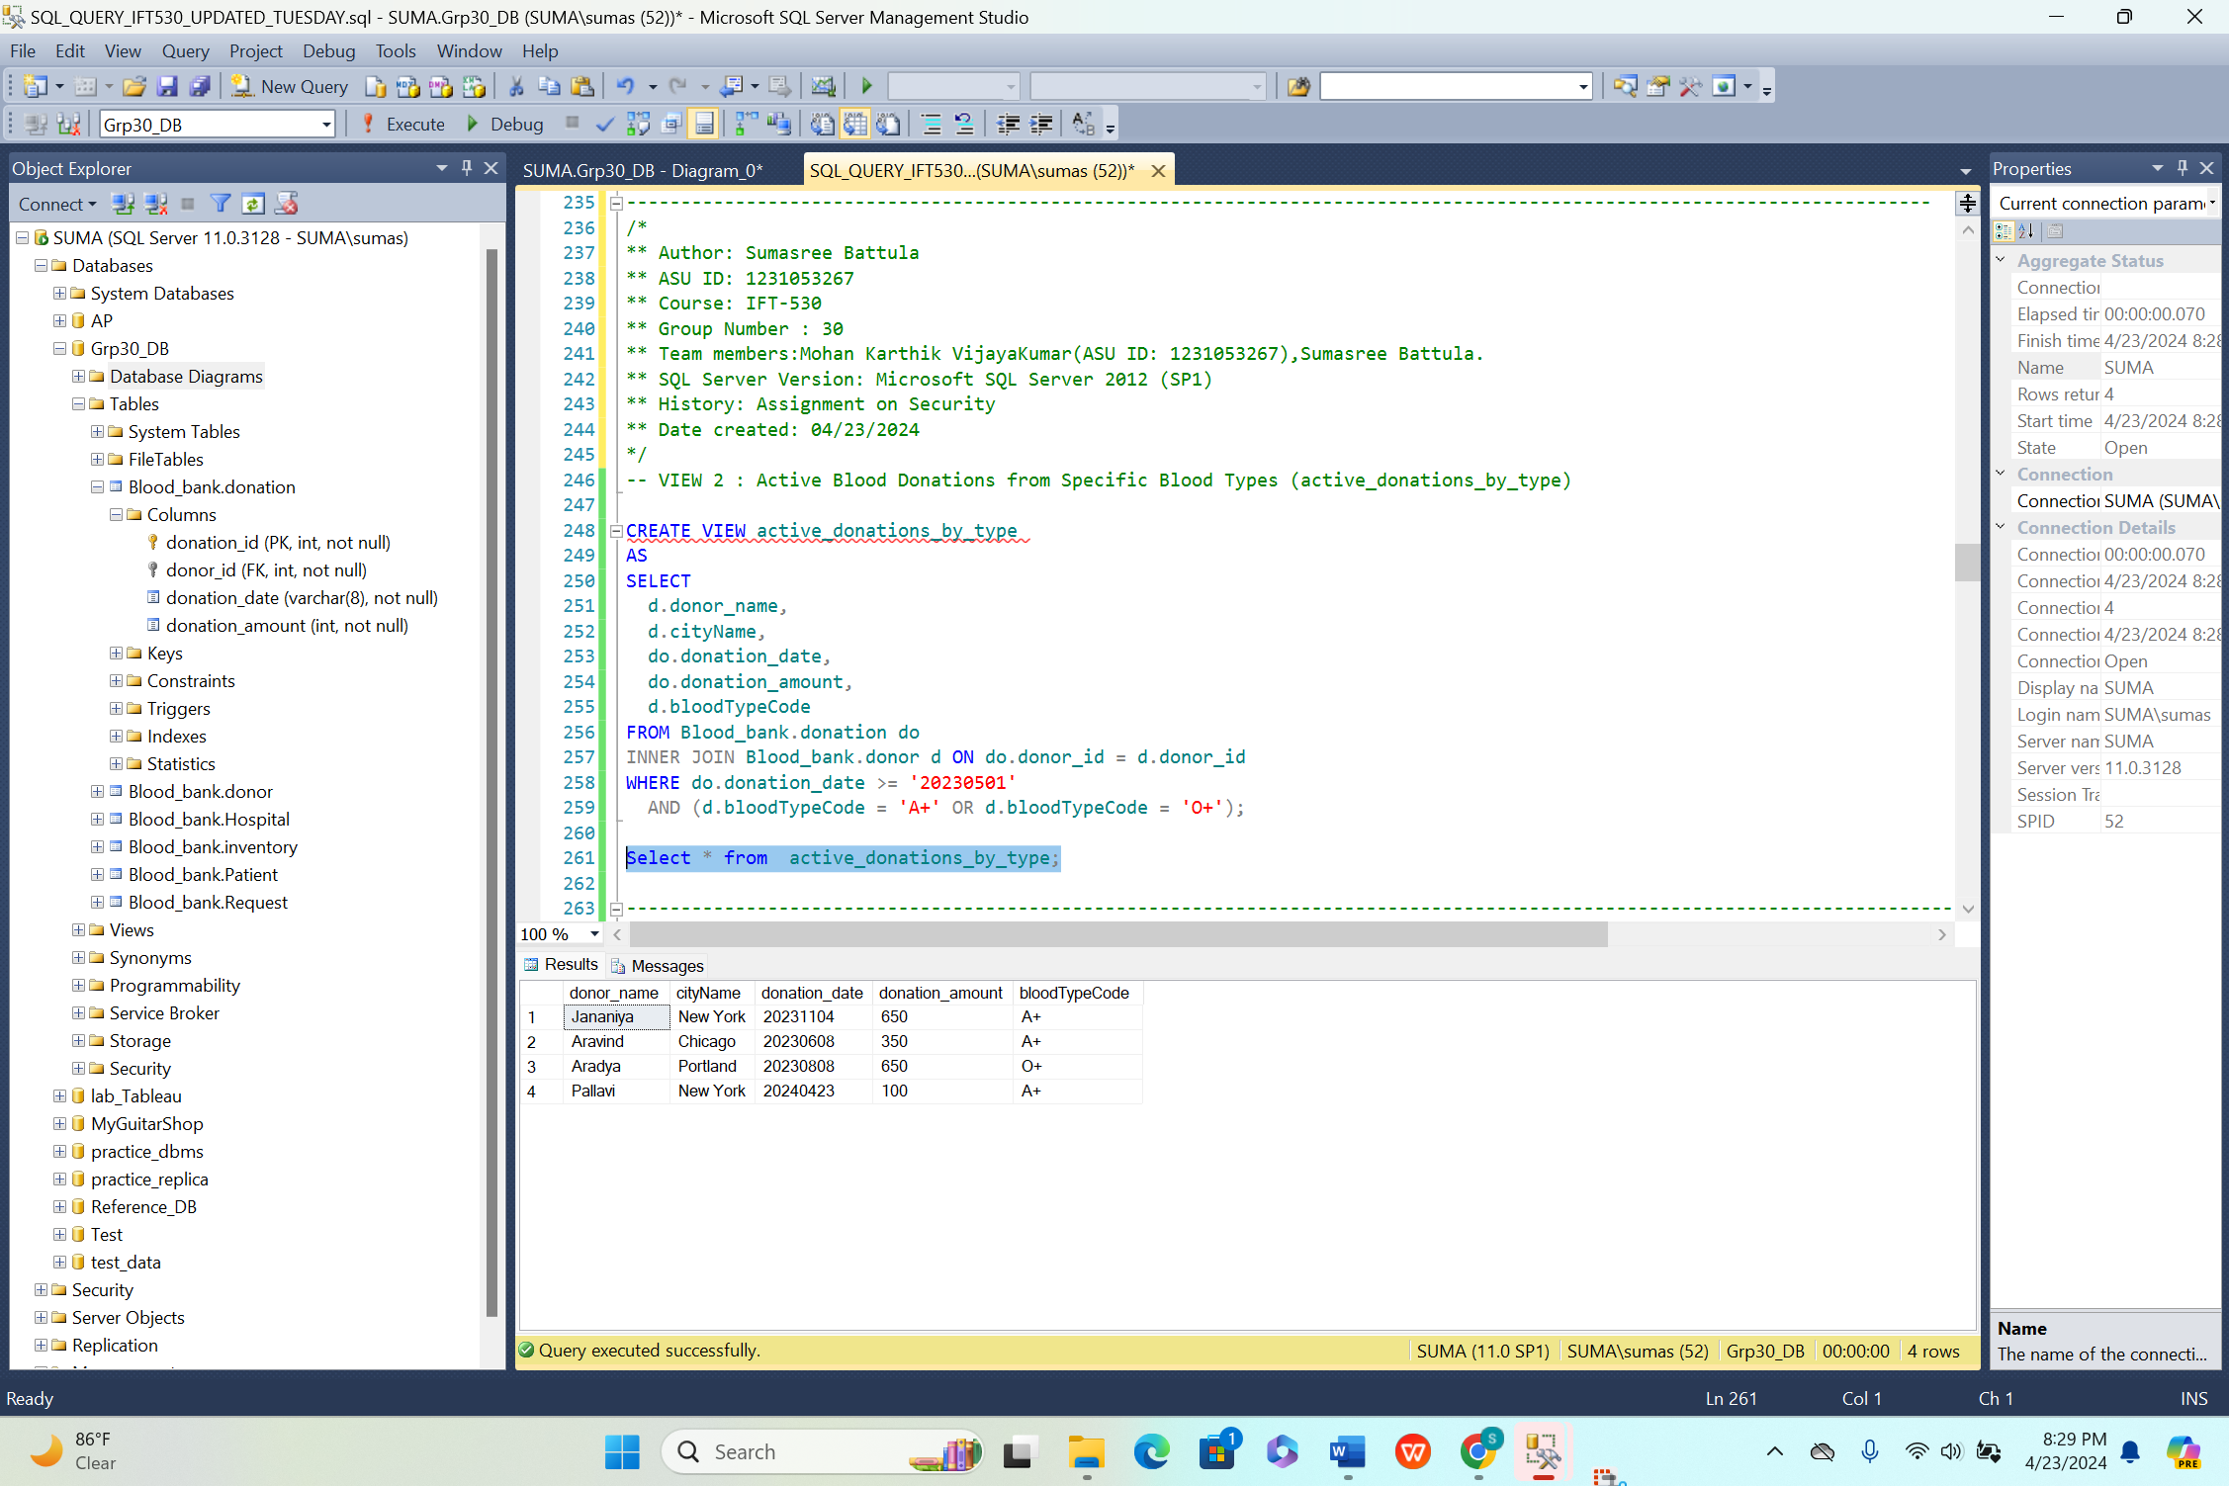

This view shows recent blood donations for specific blood types (like the in-demand A+ and O+). It lets blood bank managers see details about each donor, including name, city, donation date, amount donated, and blood type. This helps them track recent donations, especially for blood types that are needed most. They can also filter donations by date to focus on the latest contributions.

**View 3:**

**Code:**

--VIEW 3: Low Inventory Blood Types (low_inventory)

CREATE VIEW low_inventory

AS

SELECT

bloodTypeCode,

expiration_date,

quantity_available

FROM Blood_bank.inventory

WHERE quantity_available <= 40;

-- Filter for quantities below 40 units

Select * from low_inventory;

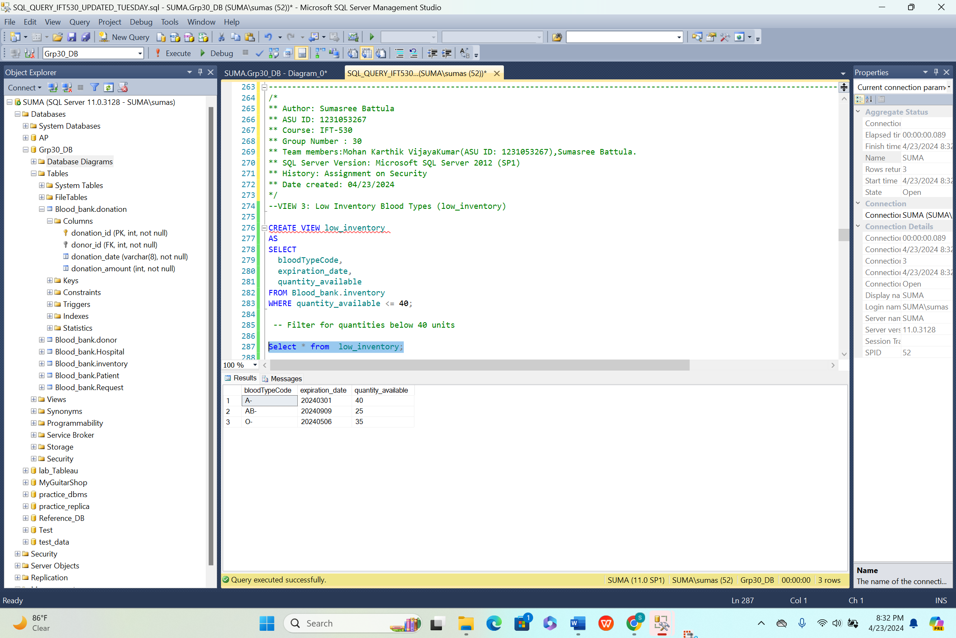

Query shows blood types that are running low. It lists the blood type code, expiration date, and how many units are left. This helps blood bank managers see which blood types are critically low (less than 40 units). By focusing on these shortages, they can quickly order more blood to make sure there's always enough on hand for patients who need it.

**Audit table creation:**

The Blood_bank.donor_audit table records all changes made to donor information in the blood bank database. It stores details like donor ID, name, age, gender, city, blood type, last donation date, operation type (insert, update, or delete), and modification timestamp. This audit trail is crucial for monitoring changes, detecting errors, and preserving data accuracy. Triggers like donor_insert_trigger, trg_donor_update, donor_delete_trigger automatically update the audit table when donors are added, edited, or removed. Users can analyze donor modification history by querying Blood_bank.donor_audit, ensuring transparency and responsibility in database maintenance. This functionality is vital for compliance, audits, and resolving data inconsistencies.

CREATE TABLE Blood_bank.donor_audit (

audit_id INT NOT NULL IDENTITY(1,1) PRIMARY KEY, -- Use IDENTITY for auto-increment

donor_id INT NOT NULL,

donor_name VARCHAR(50) NOT NULL,

age INT NOT NULL,

gender VARCHAR(1) NOT NULL,

cityName VARCHAR(50) NOT NULL,

bloodTypeCode VARCHAR(3) NOT NULL,

last_Donated VARCHAR(10) NOT NULL,

operation VARCHAR(10) NOT NULL, -- Insert, Update, Delete

modified_at DATETIME NOT NULL DEFAULT CURRENT_TIMESTAMP,

FOREIGN KEY (donor_id) REFERENCES Blood_bank.donor(donor_id)

);

select * from Blood_bank.donor_audit;

---------------Insert Trigger

CREATE TRIGGER donor_insert_trigger

ON Blood_bank.donor

AFTER INSERT

AS

BEGIN

INSERT INTO Blood_bank.donor_audit (donor_id, donor_name, age, gender, cityName, bloodTypeCode, last_Donated, operation)

SELECT

inserted.donor_id,

inserted.donor_name,

inserted.age,

inserted.gender,

inserted.cityName,

inserted.bloodTypeCode,

inserted.last_Donated,

'Insert'

FROM inserted;

END;

--------------------Update Trigger

CREATE TRIGGER trg_donor_update

ON Blood_bank.donor

AFTER UPDATE

AS

BEGIN

INSERT INTO Blood_bank.donor_audit

(donor_id, donor_name, age, gender, cityName, bloodTypeCode, last_Donated, operation, modified_at)

SELECT

donor_id, donor_name, age, gender, cityName, bloodTypeCode, last_Donated, 'Update', GETDATE()

FROM inserted;

END;

--------------------Delete Trigger

CREATE TRIGGER donor_delete_trigger

ON Blood_bank.donor

AFTER DELETE

AS

BEGIN

-- Insert the deleted record into the donor_audit table

INSERT INTO Blood_bank.donor_audit (donor_id, donor_name, age, gender, cityName, bloodTypeCode, last_Donated, operation)

SELECT

d.donor_id,

d.donor_name,

d.age,

d.gender,

d.cityName,

d.bloodTypeCode,

d.last_Donated,

'Delete'

FROM deleted d;

END;

---Testcases

INSERT INTO Blood_bank.donor values(130, 'Pallavi', 21, 'F', 'New York', 'A+', '20230611');

Update Blood_bank.donor

Set donor_name = 'Jhansi'

where donor_id = 130;

Update Blood_bank.donor

Set last_donated = '20230612'

where donor_id = 130;

DELETE FROM Blood_bank.donor_audit

WHERE donor_id = 130;

select * from Blood_bank.donor_audit;

select * from Blood_bank.donor;

select * from Blood_bank.donation;

**Audit table creation:**

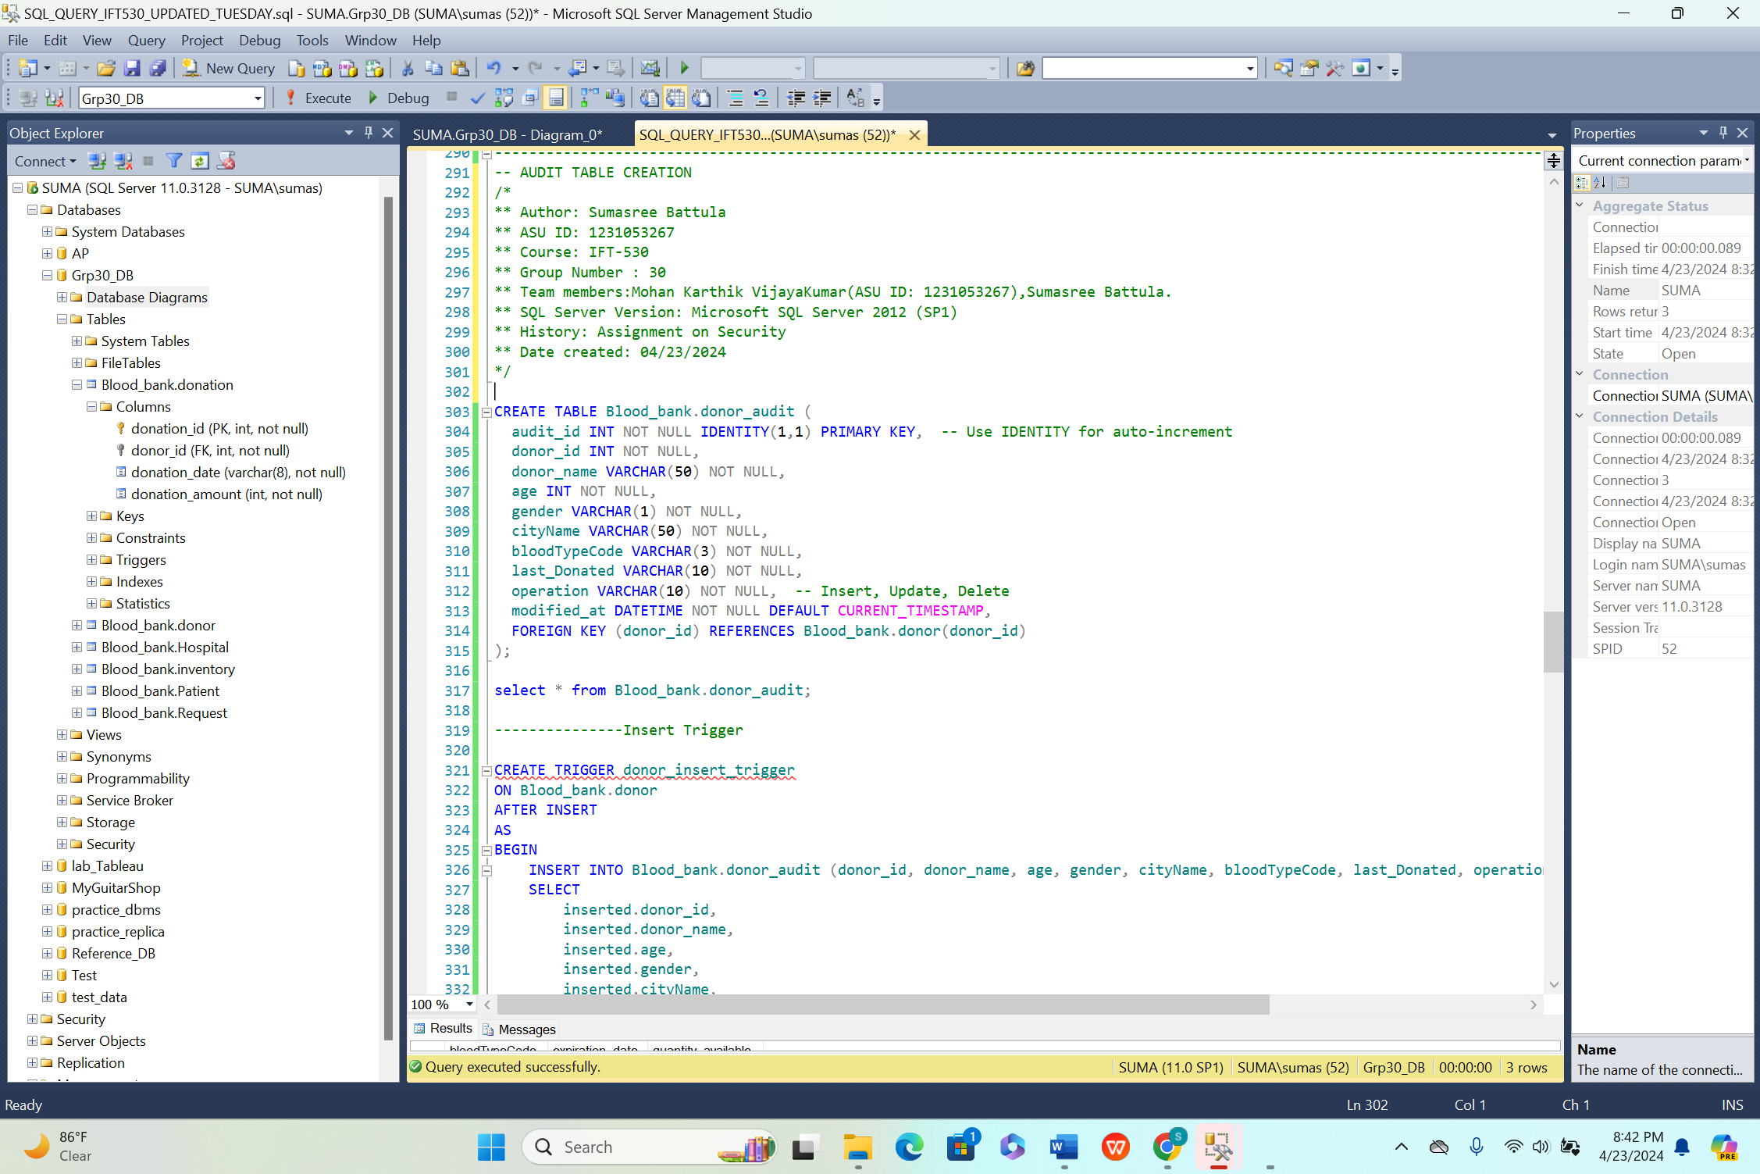

**Insert trigger:**

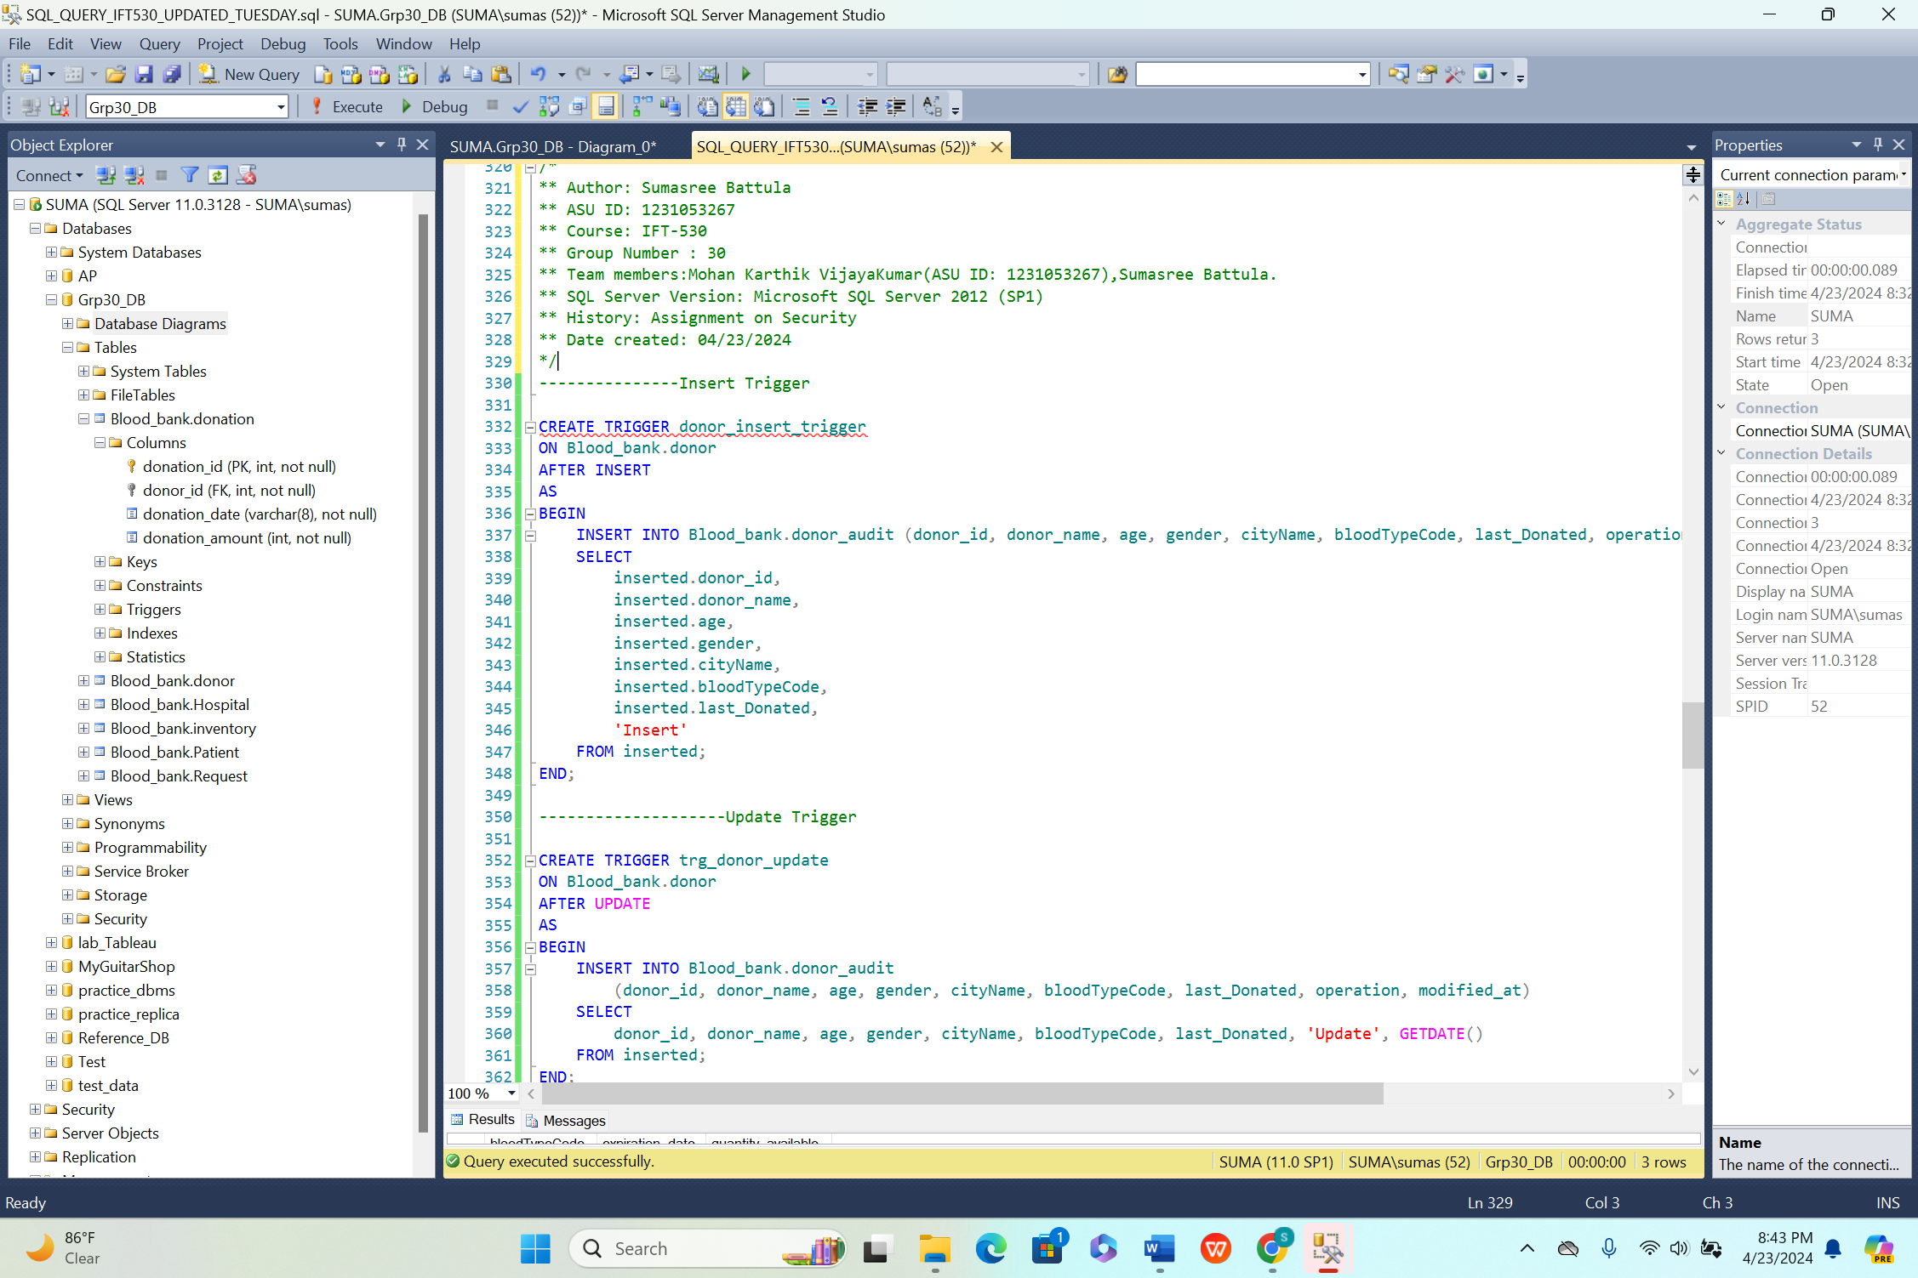**Update trigger:**

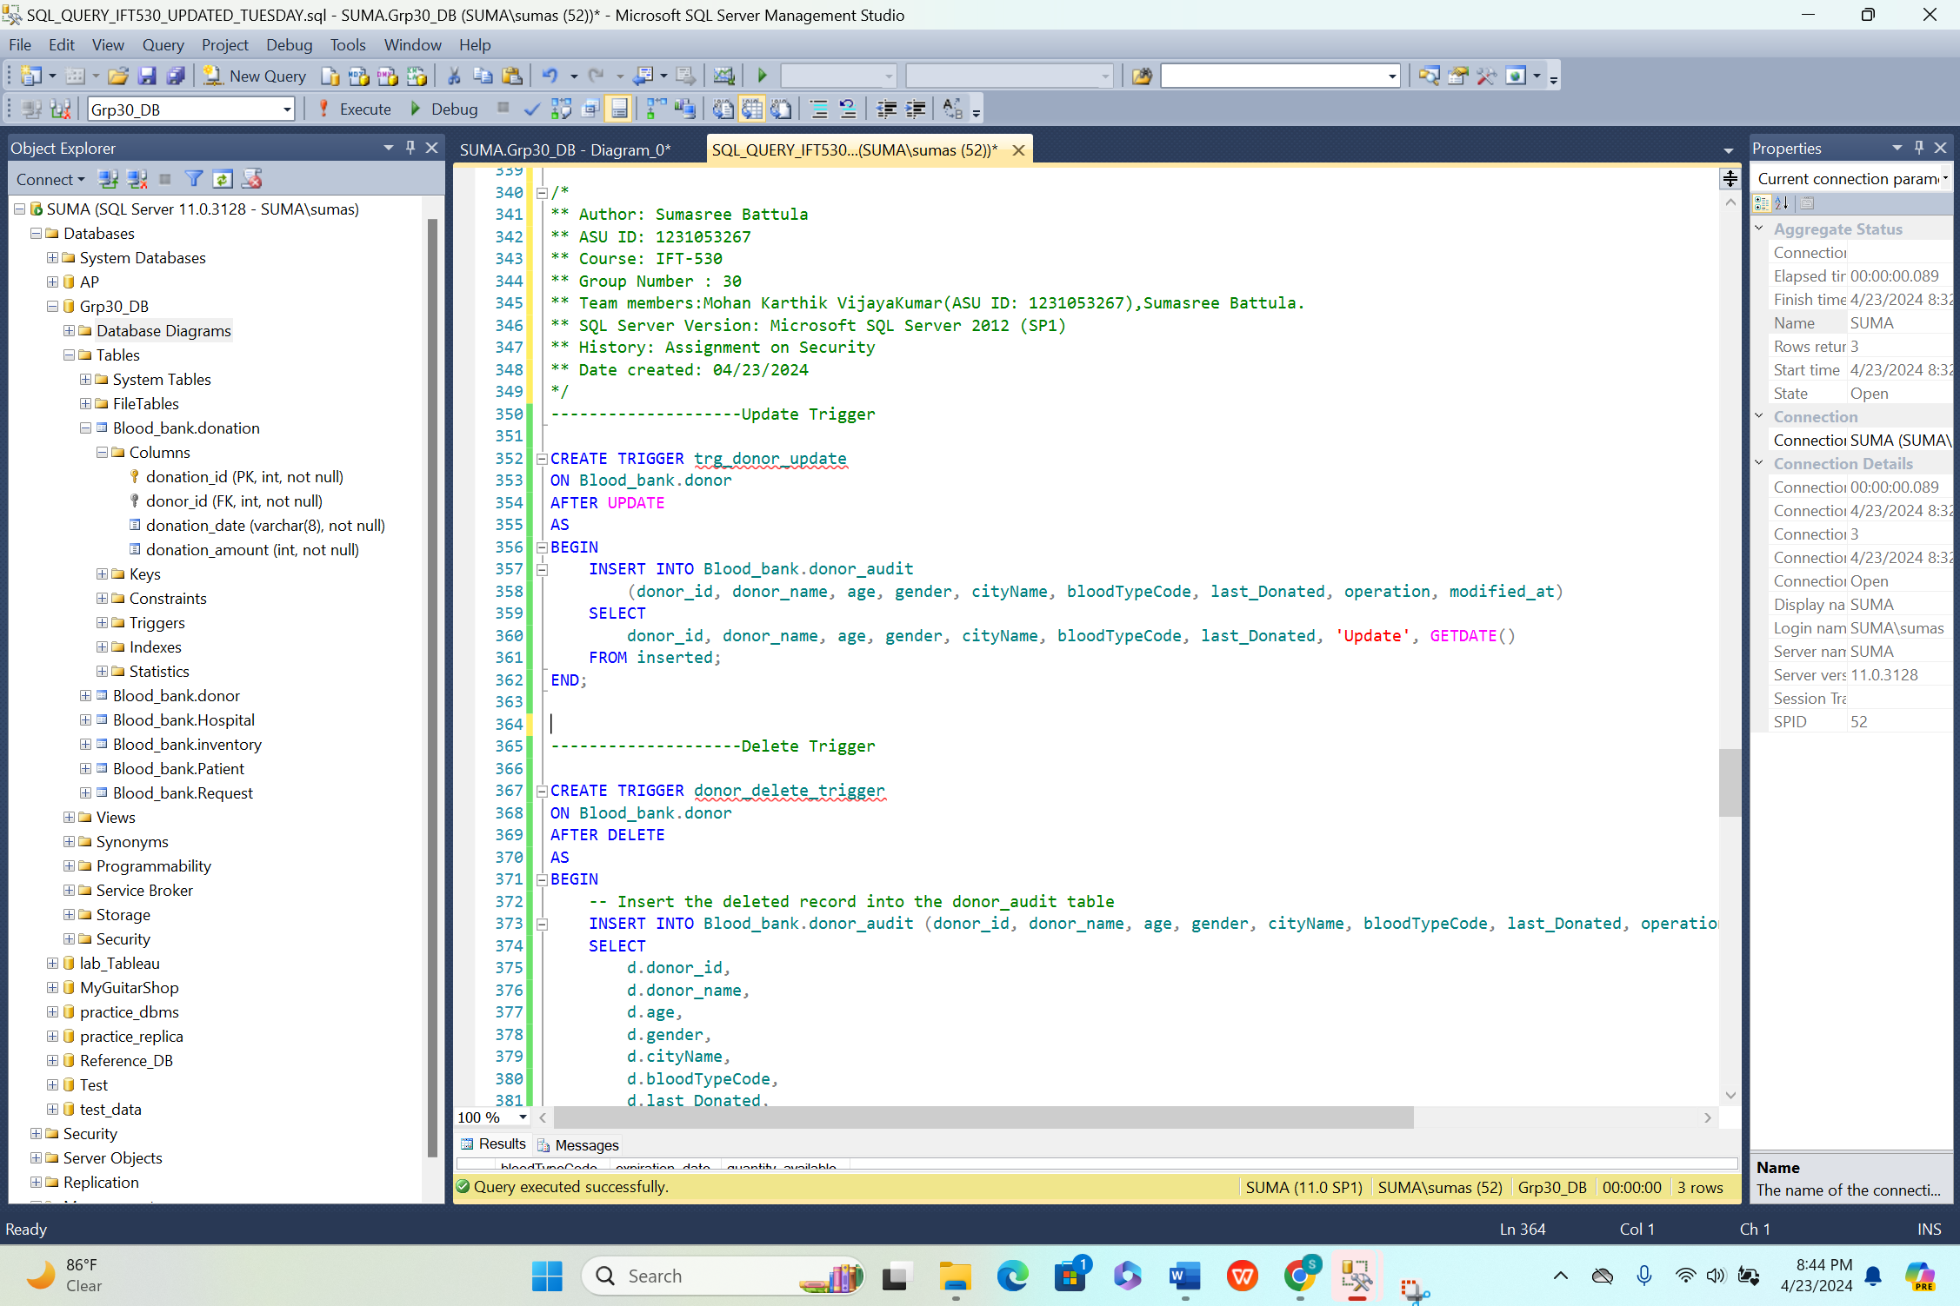

**Delete trigger:**

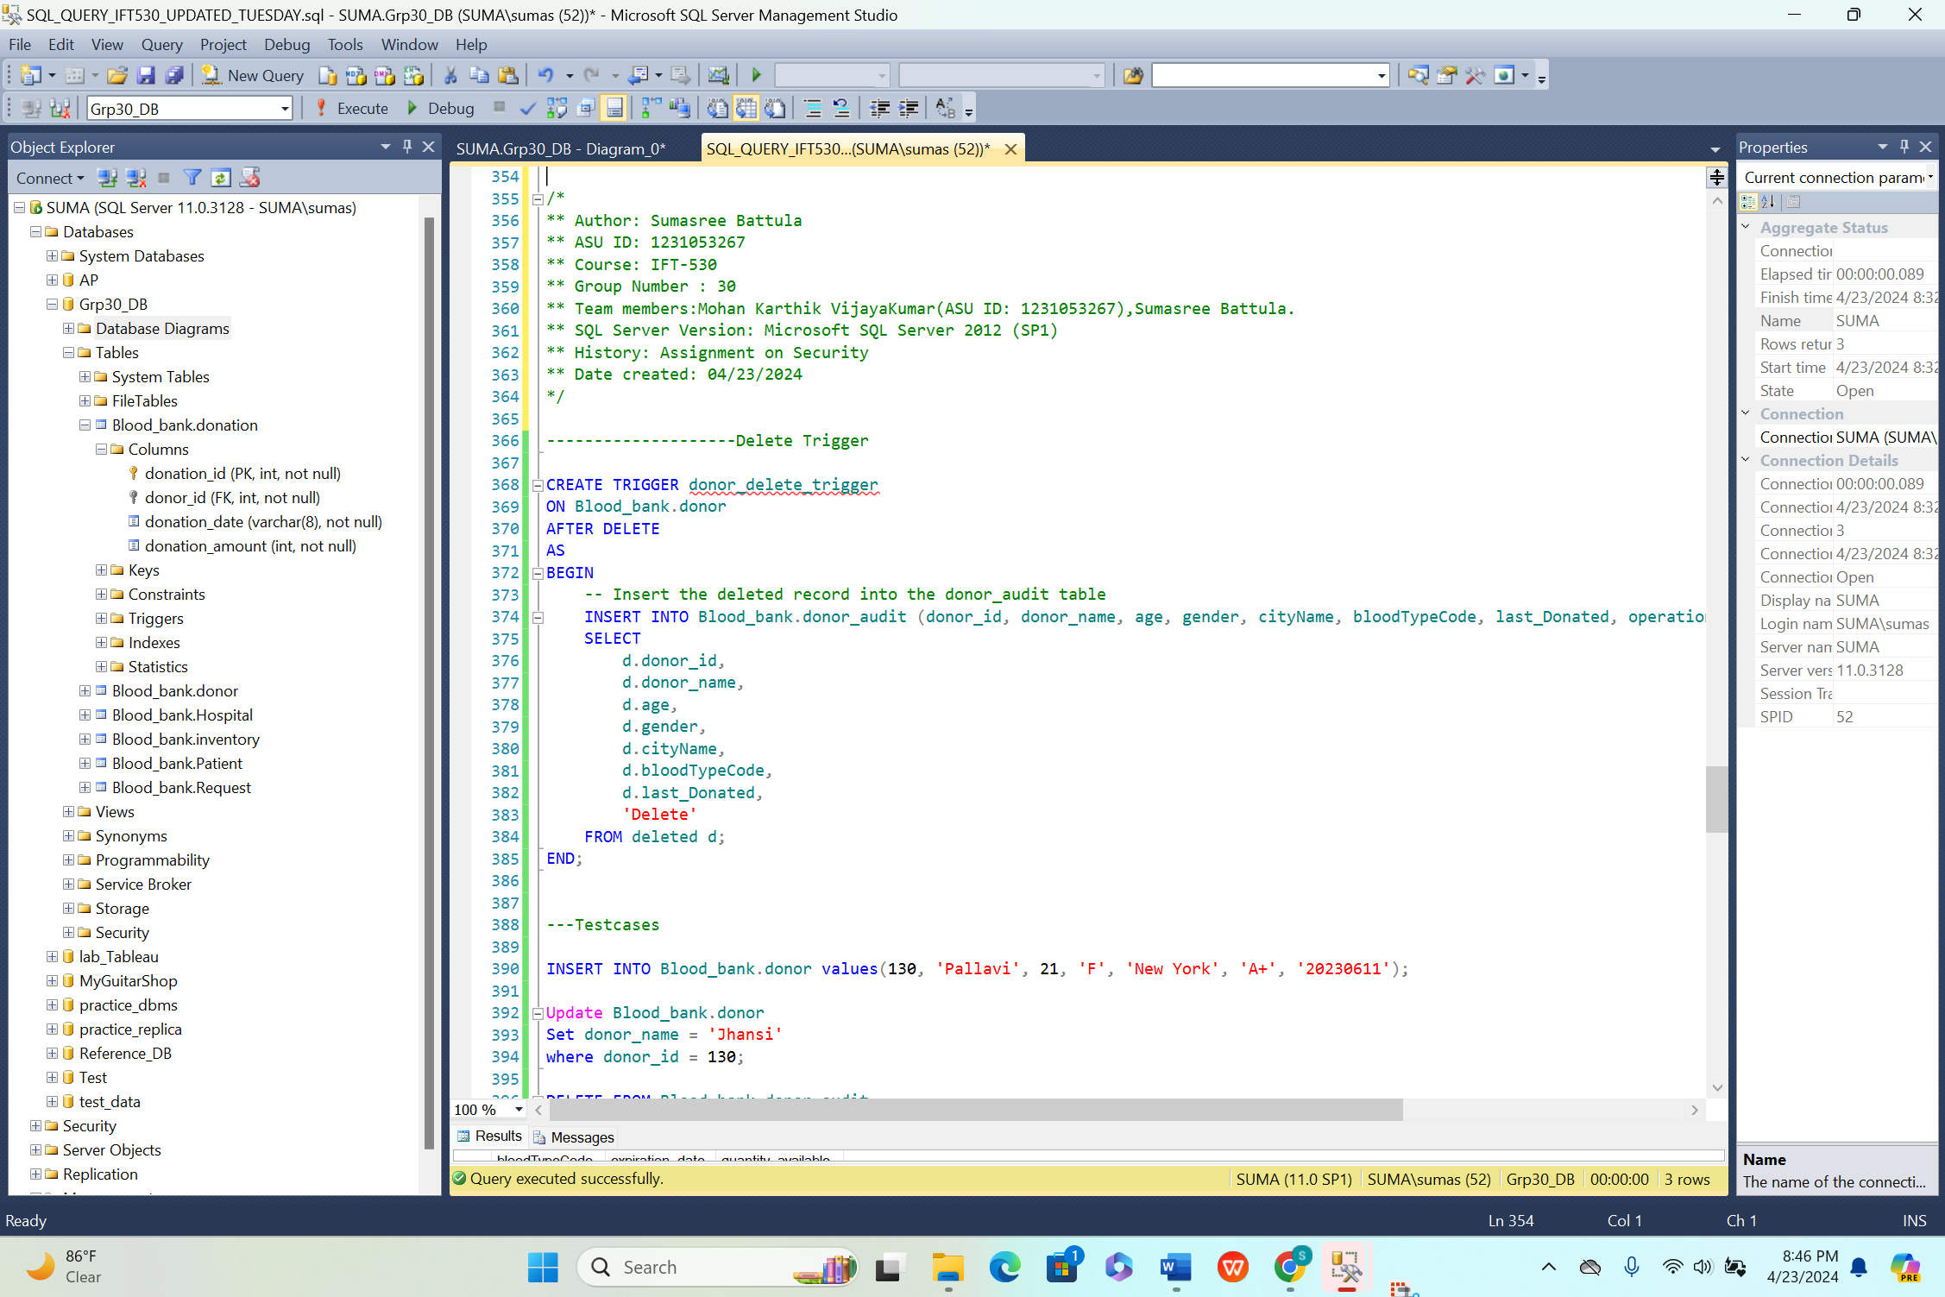**Testcases statements for insertion, updation or deletion:**

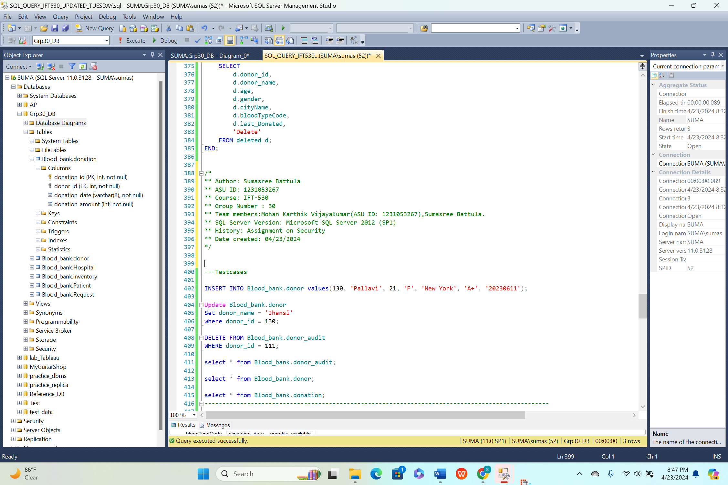

**Output snippets: For Insert trigger:**

**Before insertion: Output for both donor and donor_audit table snippets respectively:** 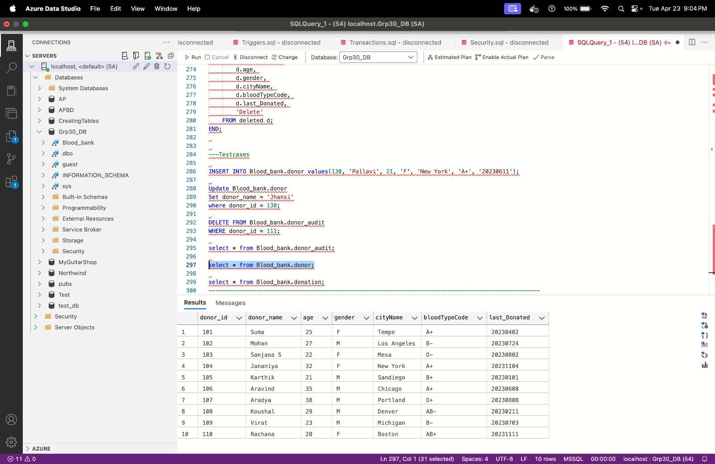

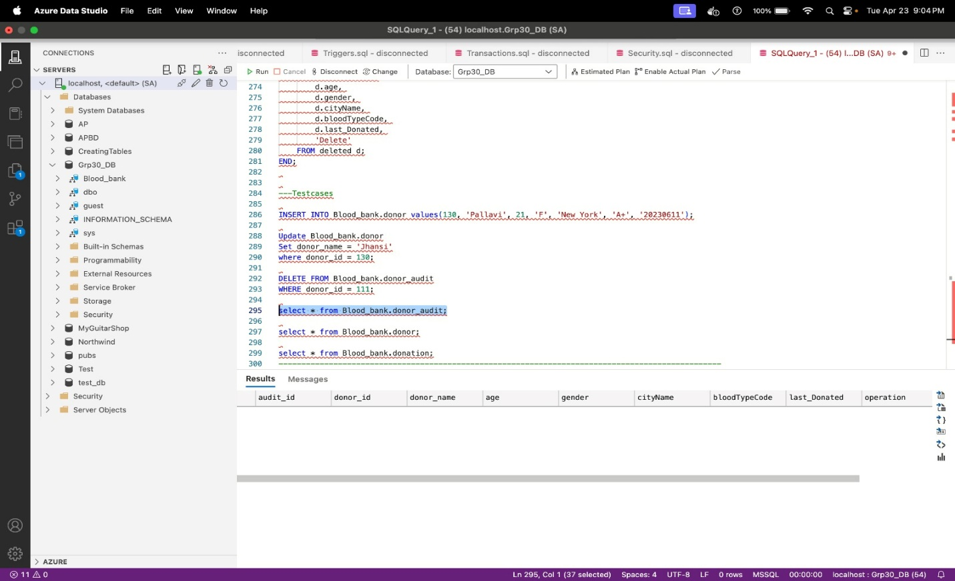

**After insertion through trigger: Output for both donor and donor_audit table snippets:** 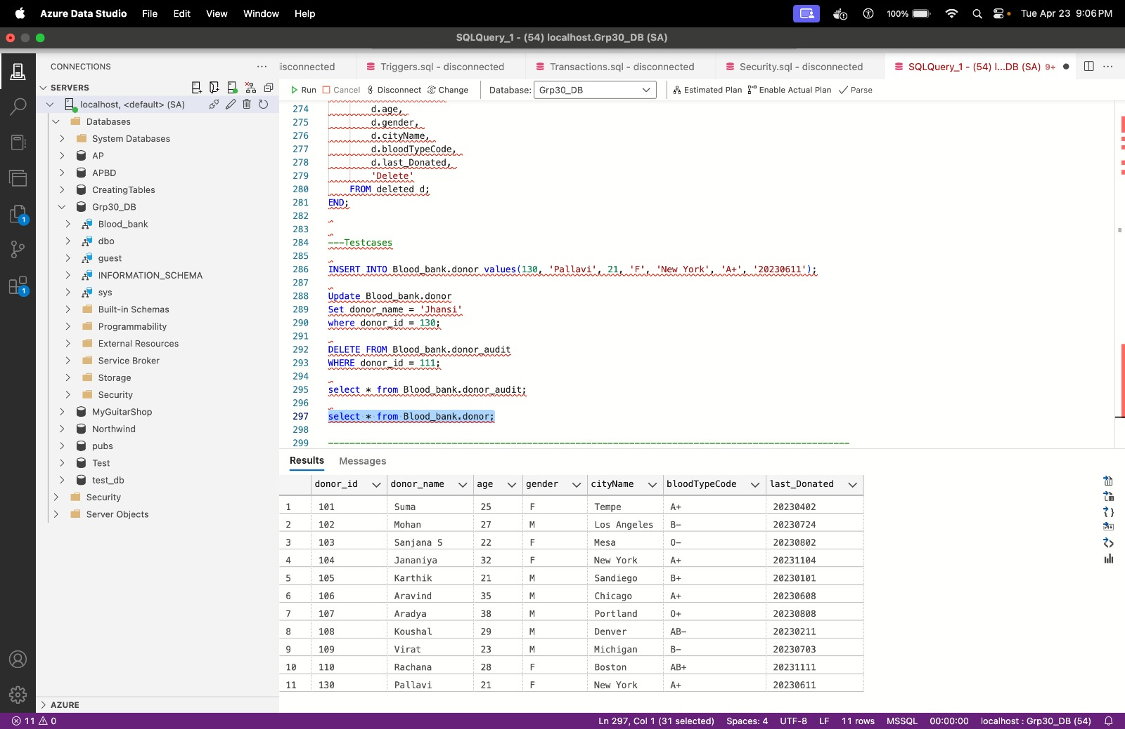

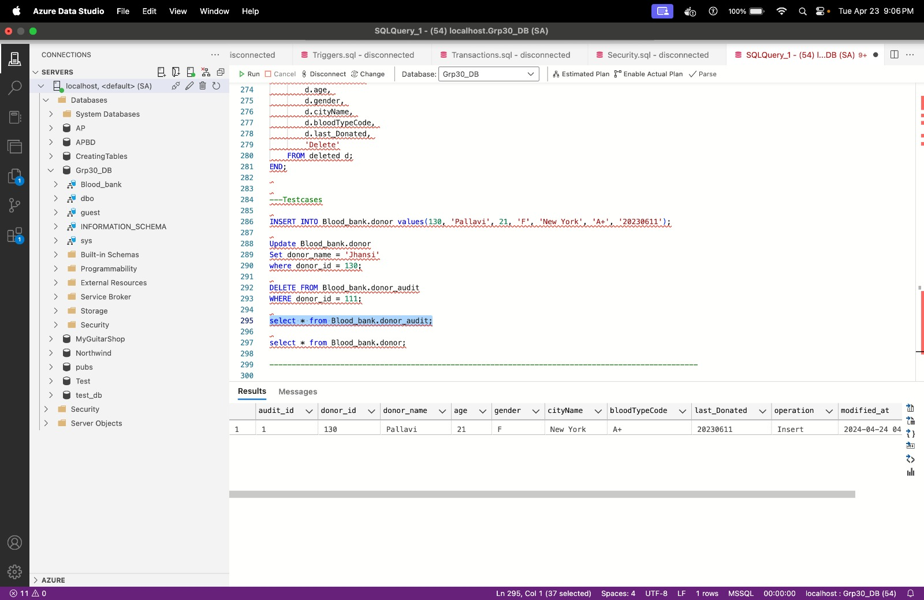

**For Update trigger snippet: For donor and donor_audit table snippet respectively.**

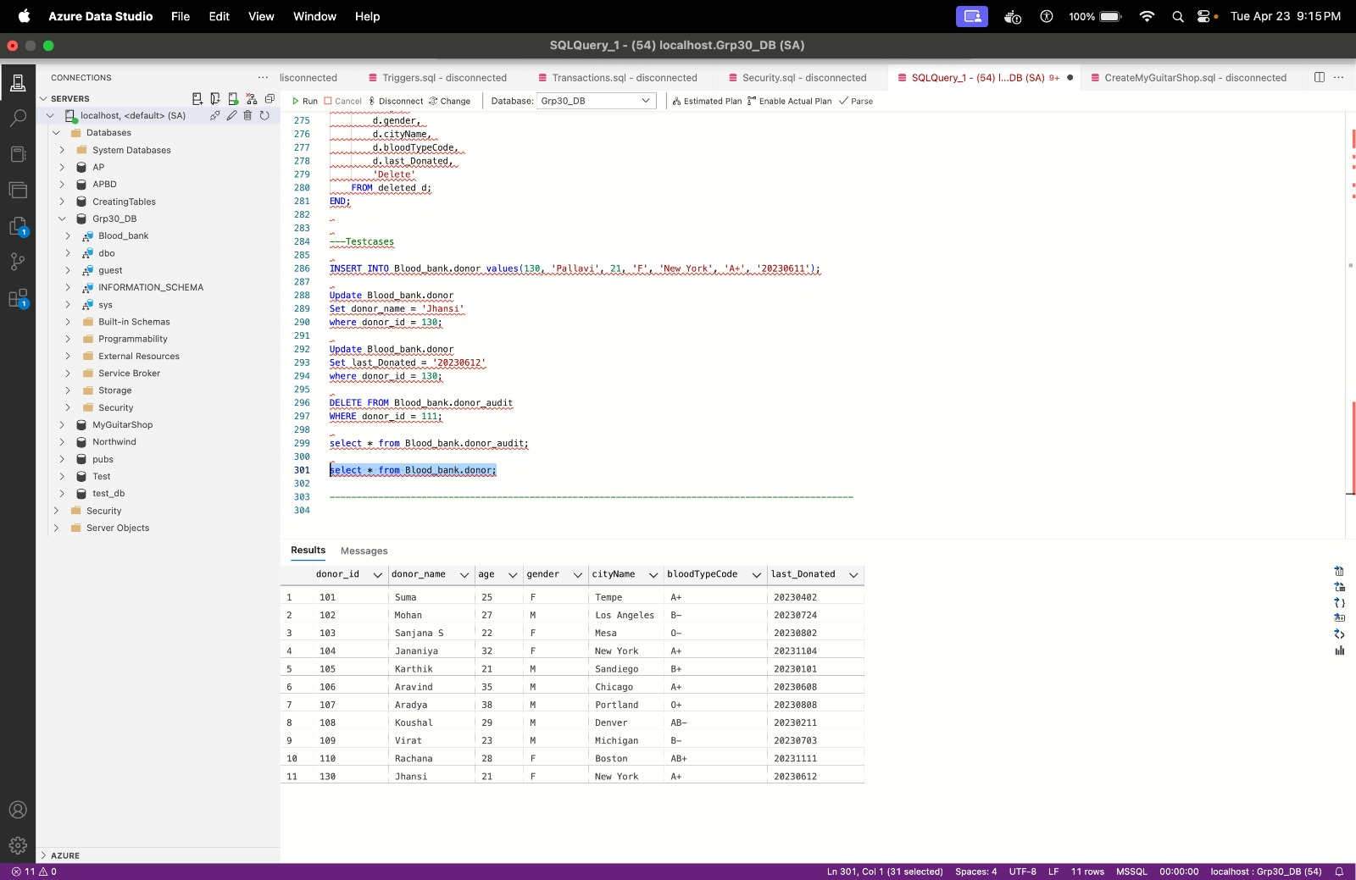

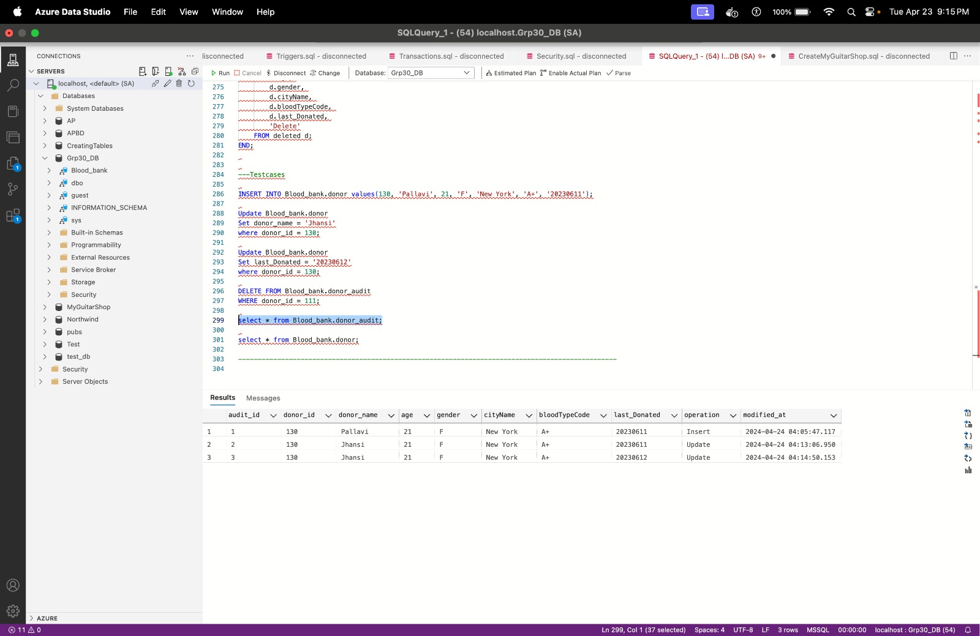

**For Deletion Operation:**

**After deletion: For Donor_audit table snippet:**

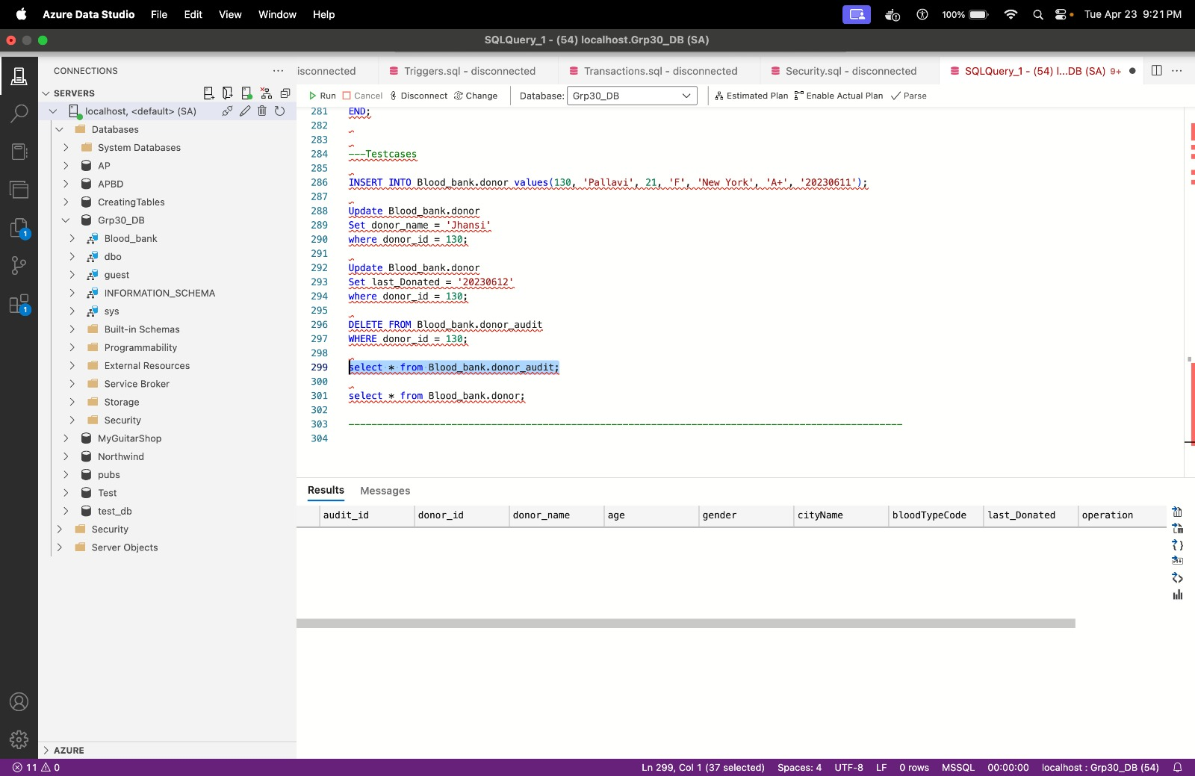

**Stored procedure:**

The spAddDonation stored procedure simplifies the process of adding a new donation entry to the blood bank database. By accepting parameters such as donation ID, donor ID, donation date, and amount, it inserts these details into the Blood_bank.donation table. Moreover, it updates the last donation date for the corresponding donor in the Blood_bank.donor table. This procedure guarantees data consistency and precision by managing both insertion and update tasks within a single, controlled transaction. It streamlines donation management responsibilities, minimizing error possibilities, and ensuring swift updates to donor records with the most recent donation data.

CREATE PROCEDURE spAddDonation

@donation_id INT,

@donor_id INT,

@donation_date VARCHAR(8),

@donation_amount INT

AS

BEGIN

-- Insert a new record into the donations table

INSERT INTO Blood_bank.donation (donation_id, donor_id, donation_date, donation_amount)

VALUES (@donation_id, @donor_id, @donation_date, @donation_amount);

-- Update last donated date in the donor table

UPDATE Blood_bank.donor

SET last_Donated = @donation_date

WHERE donor_id = @donor_id;

END;

GO

-----DROP stored procedure

DROP PROCEDURE spAddDonation;

GO

**Code and Output snippet:**

**Stored procedure inserts and updates value to donation and donor table respectively:**

**Insertion to donation table:**

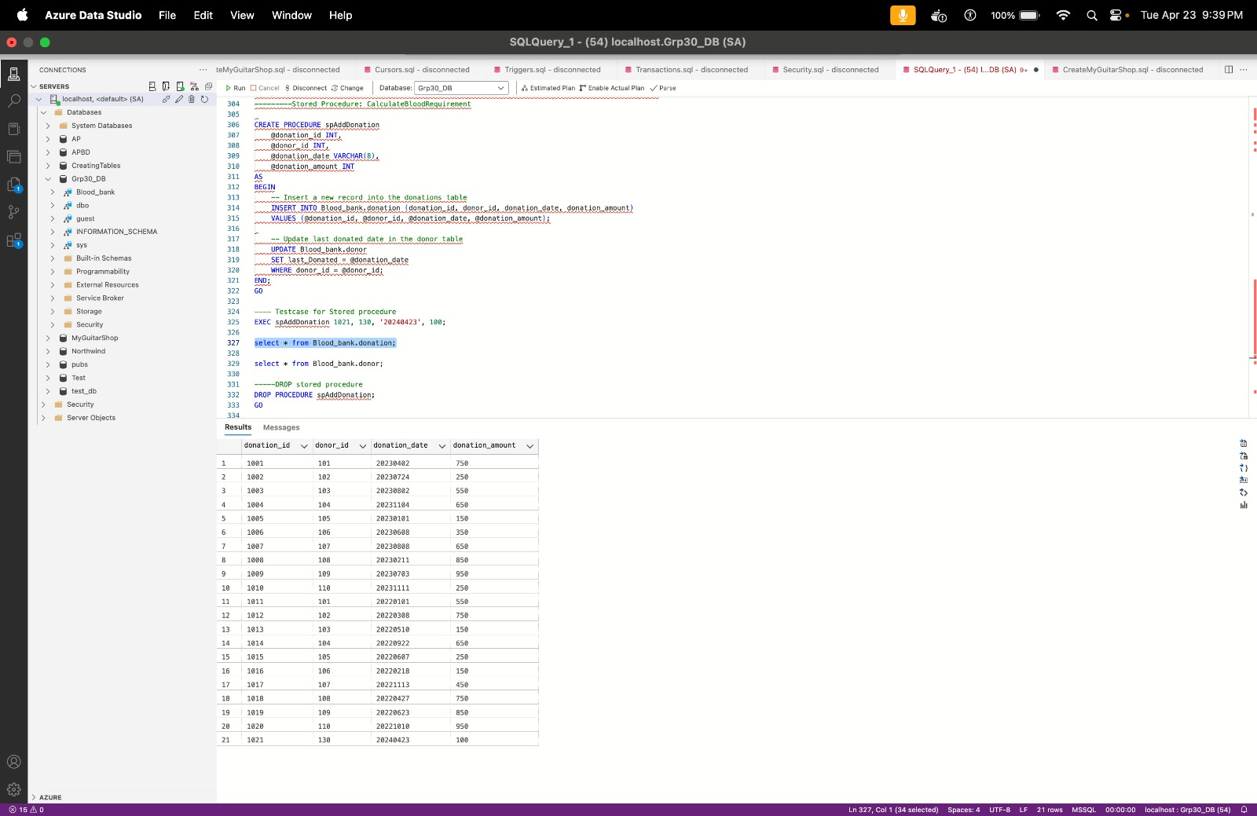

**Stored procedure updates the last_donated column for donor table**

**Update values for donor table:**

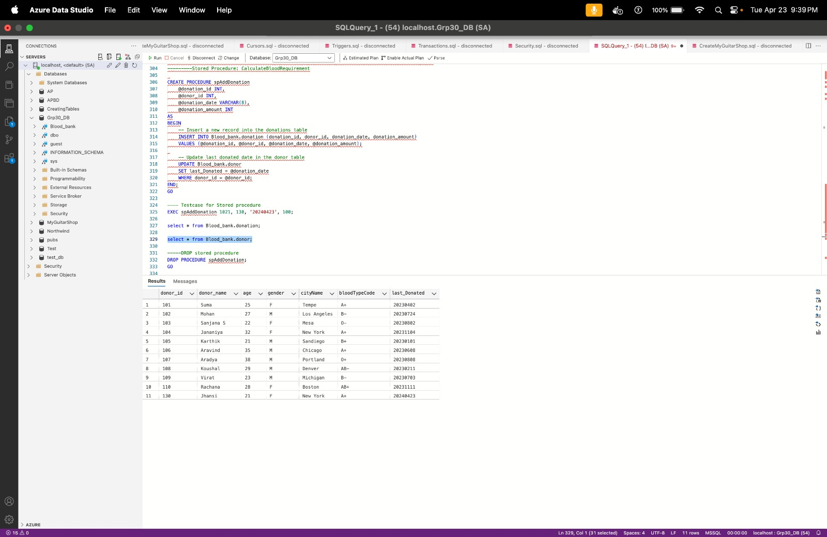

**After Deletion of stored procedure:** 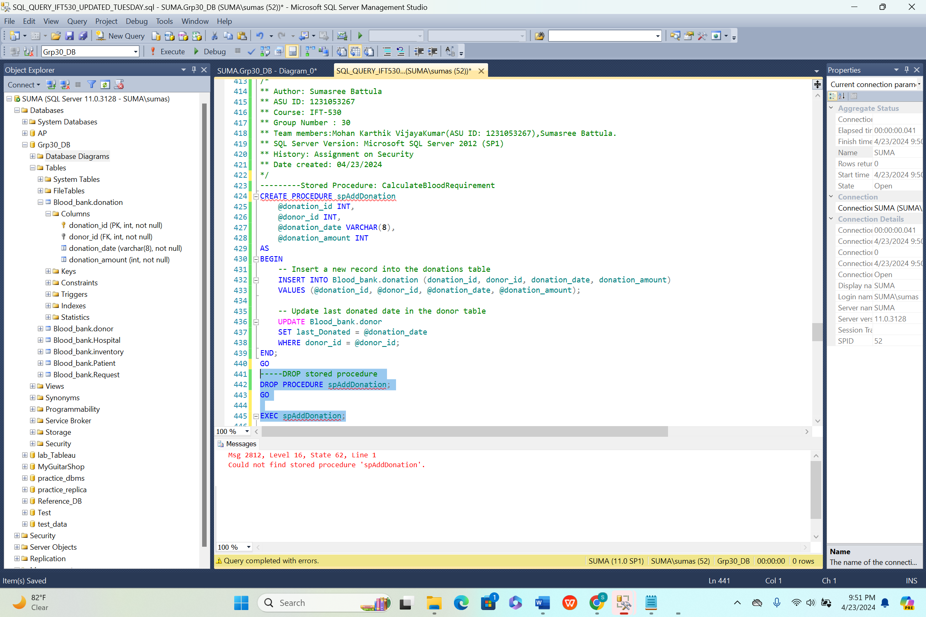

**User defined function:**

The fnTotalDonations user-defined function computes the total donation amount attributed to a specified donor ID. It retrieves donation amounts from the Blood_bank.donation table and aggregates them based on the provided donor ID. This function furnishes users with an effortless means to access summarized donation insights for individual donors, eliminating the need for manual calculations. It amplifies data analysis capabilities, empowering users to gauge donor contribution levels and make well-informed decisions informed by donation trends. This functionality proves invaluable for monitoring donor engagement, gauging campaign effectiveness, and pinpointing leading contributors within the blood bank infrastructure.

IF OBJECT_ID('dbo.fnTotalDonations', 'FN') IS NOT NULL

DROP FUNCTION dbo.fnTotalDonations;

GO

CREATE FUNCTION dbo.fnTotalDonations (@donor_id INT)

RETURNS INT

AS

BEGIN

DECLARE @totalAmount INT;

SELECT @totalAmount = ISNULL(SUM(donation_amount), 0)

FROM Blood_bank.donation -- Assuming Blood_bank is your schema

WHERE donor_id = @donor_id;

RETURN @totalAmount;

END;

GO

----Drop user stored procedure

DROP FUNCTION fnTotalDonations;

GO

---- Testcase for User Defined procedure

SELECT dbo.fnTotalDonations(101) AS TotalDonations;

**Code and output snippet:**

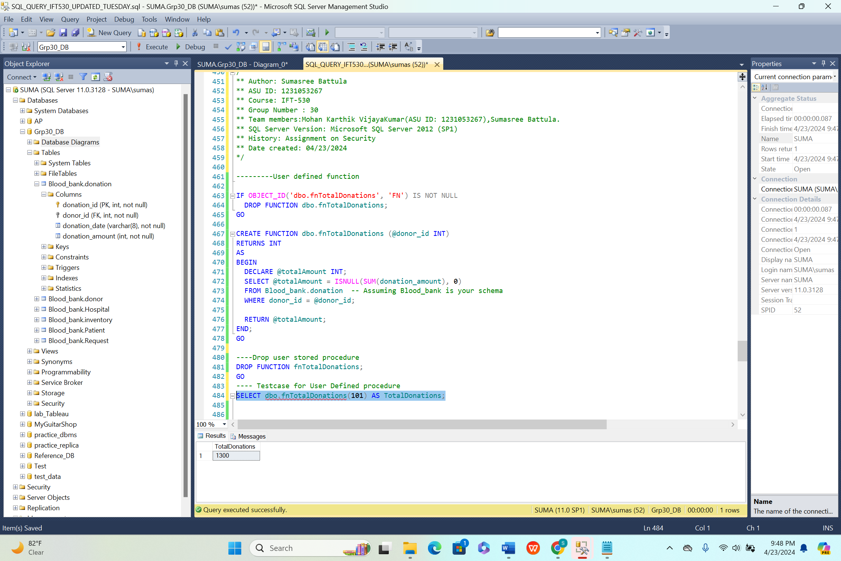

**For Deletion: After Deletion of user defined function**

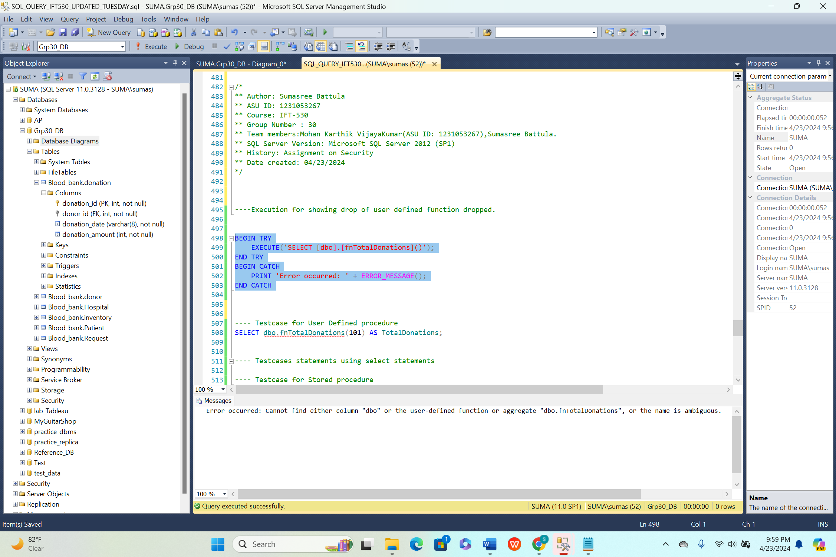

**Cursor:**

This cursor script retrieves donor records with blood type 'B+' from the Blood_bank.donor table and processes each record individually. It's useful for users needing to perform specific actions or operations on a subset of data meeting certain criteria. For example, it could be used to generate reports, perform calculations, or update records for donors with a particular blood type. Cursors provide a way to iterate through result sets row by row, allowing for custom processing logic. However, they should be used judiciously due to potential performance implications, especially with large datasets.

Code:

--creating cursor:

DECLARE blood_cursor CURSOR FOR

SELECT donor_id, donor_name, bloodTypeCode

FROM Blood_bank.donor

WHERE bloodTypeCode = 'B+';

OPEN blood_cursor;

---Processing loop:

DECLARE @donor_id INT;

DECLARE @donor_name VARCHAR(50);

DECLARE @blood_type VARCHAR(3);

FETCH NEXT FROM blood_cursor INTO @donor_id, @donor_name, @blood_type;

WHILE @@FETCH_STATUS = 0

BEGIN

-- Process each donor record here (e.g., print details)

PRINT 'Donor ID: ' + CAST(@donor_id AS VARCHAR(10)) + ', Name: ' + @donor_name + ', Blood Type: ' + @blood_type;

FETCH NEXT FROM blood_cursor INTO @donor_id, @donor_name, @blood_type;

END;

CLOSE blood_cursor;

DEALLOCATE blood_cursor;

Code and output snippet:

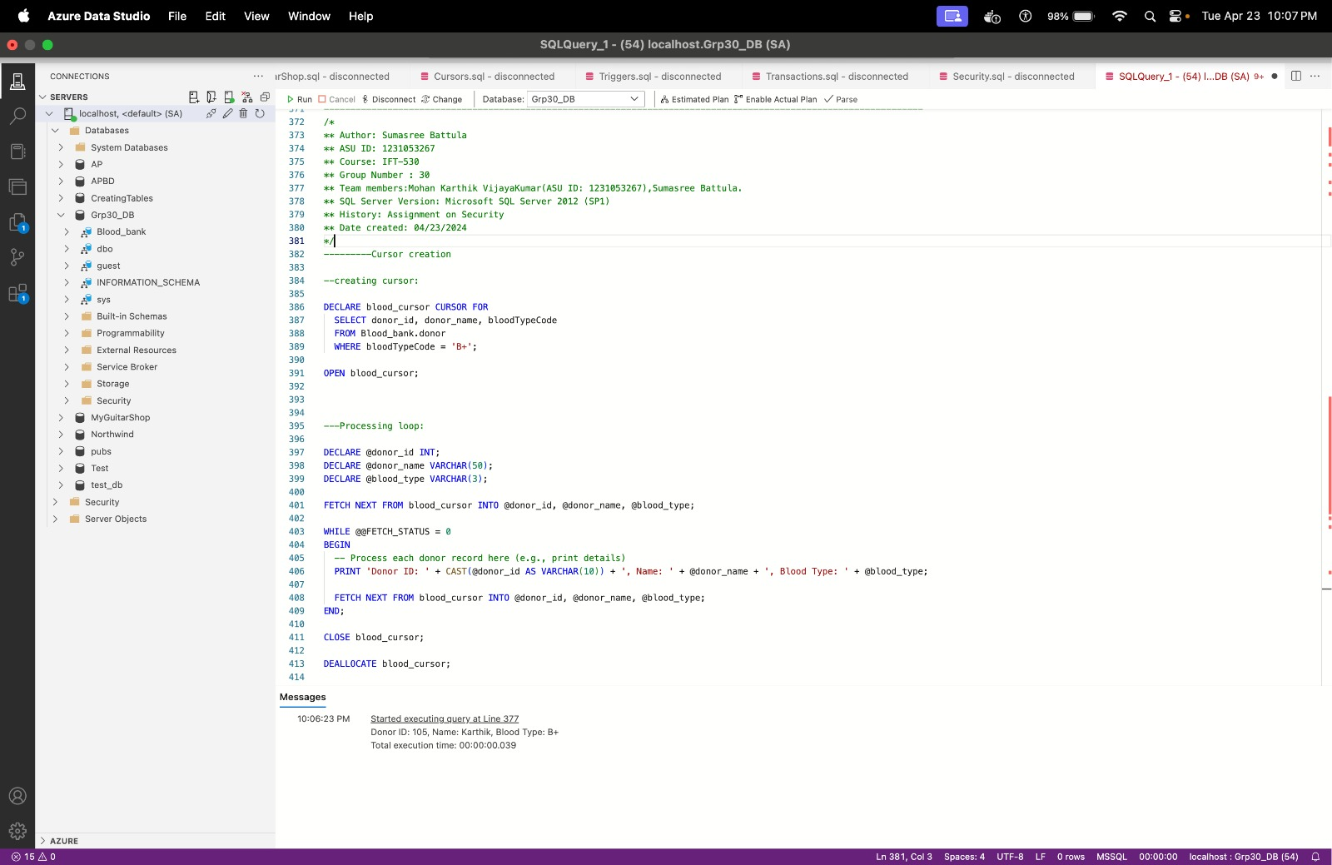

**REFRENCES:**

* Halpin, T., 2015, Object-Role Modelling Fundamentals
* Murach. J, Syverson. J., 2016, Murach’s SQL server 2016 for developers